Everyday Science
Level 6

Unit one: Introduction to Science
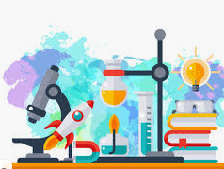
The study of the things and events that take place around us is called Science.
A person who studies science is called a scientist.
A scientist uses scientific methods to solve problems. He or she works in a special kind of classroom called a laboratory.

Kinds of instruments used by a scientist:
Balance: A balance is an instrument used for measuring the mass of a body. Mass is measured in grams. 1 kilograms = 1000 grams.
Thermometer: A thermometer is used to measure the temperature of a body. It tells how hot or cold a body is.
Safety rules for using a laboratory :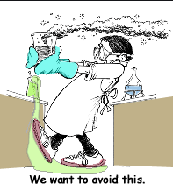
- Do not touch anything without the teacher's permission.
- Follow the instruction given by the teacher.
- Always put back things in their proper place after use.
- Put stoppers on the reagent bottles immediately after use.
- Report all damage to the laboratory in charge.

Unite Two: Living things
Everything on the Earth is either living or non-living. The non-living part of the Earth is made up of rocks, soil, water, air and sunlight, whereas the living part is made up of plants and animals.

Characteristics of living things:
- Feeding:
Living things take in materials from their surroundings that they use for growth or to provide energy, green plants can make their own food by photosynthesis. They use sunlight, carbon dioxide from the air and water from the soil to make simple sugars such as glucose.

- Respiration
All living things need energy to perform various activities such as growth, repair and movement. They take in oxygen from their surroundings. This oxygen combines with the food and oxidizes it to release energy. Carbon dioxide is produced during this process. This process is called Respiration.

- Movement
All living things move, animals can move with the help of special parts of their bodies such as arms and legs, fins or wings. Plants can only move some parts of their bodies according to changes in their surroundings.

- Excretion
All living things excrete. As a result of the many chemical reactions occurring in cells, they have to get rid of waste products which are harmful and must be removed. The process by which toxic materials are removed from the body is called Excretion.
- Growth
Growth is seen in all living things. It involves using food to produce new Cells. The permanent increase in cell number and size is called growth.

- Reproduction
All living things produce living organisms of their kind, animals reproduce by producing eggs or babies and plant reproduce by producing spores and seeds in fruits or cones.
- Sensitivity
All living things can feel changes which take place inside or outside the bodies and they produce reactions in response to them, they are sensitive. Animal have special sense organs such as eyes and ears.

Living things are made of cells:
A cell is a unit of structure and function in all living organisms. The basic structure of all cells is the same, but they may vary in shape and size according to the type of function that they perform.
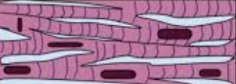 Muscle cell

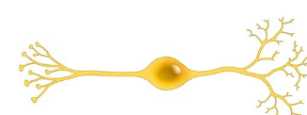 Nerve Cell

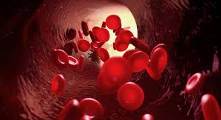

Red blood cells

Structure of a cell:
Almost all cells have the same basic structure.
Nucleus: This large, round part controls what happens in a cell by sending signals to all other parts of the cell.
Cytoplasm: This gel-like material inside a cell holds all the inner parts of a cell.
Mitochondrion: This small oval sac releases energy from food for the cell to use.
Cell membrane: This thin outer layer of a cell lets things in and out of the cell.

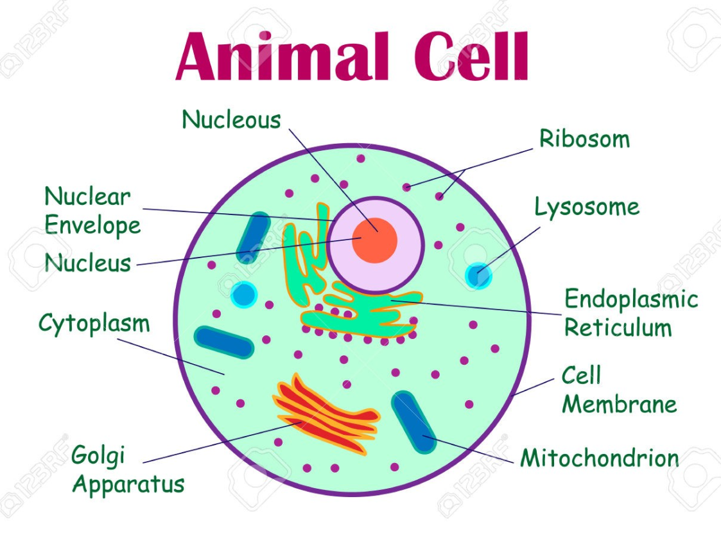

What are the parts of Plant Cell?
Plants cells have the same parts that animal cells have. However, vacuoles in plant cells are a little different from the ones in animal cells. Also, plant cells have two additional parts.

Vacuole: larger than a vacuole in an animal cell, this is a cell part that holds a lot of water and gives shape to the cell.
Cell Wall: a hard outer layer of a plant cell that protects the cell and provides support.
Chloroplast: a part of a plant cell that uses energy from sunlight to make food.

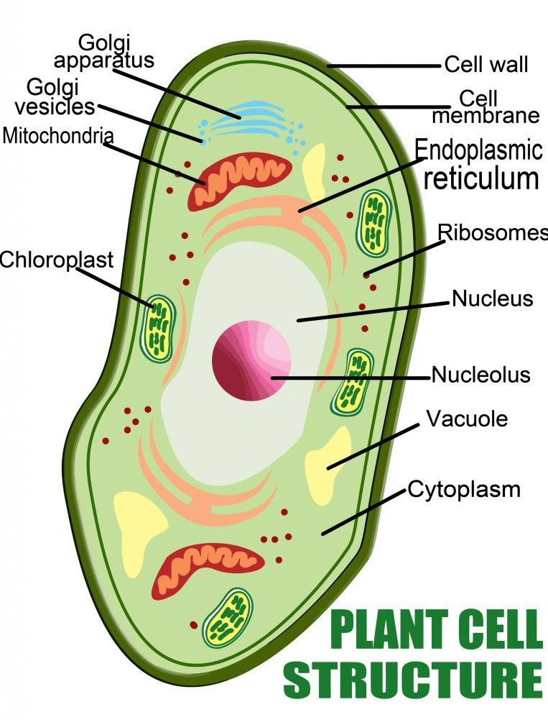

Difference between plant and animal cells:
The table below shows the function of specific features that make up animal and plant cells. Some of these features are common to animal cells and plant cells.

In plant cell? | In animal cell? | Function | Cell structure
Yes | Yes | Controls the exchange of material between the cell and its surroundings. | Cell membrane
Yes | Yes | Contain DNA arranged in chromosomes, control the activities of the cell | Nucleus
Yes | Yes | Jelly-like substance where chemical reactions of the cell occur | Cytoplasm
Yes | No | Made from Cellulose protects the cell and give its shape | Cell wall
Yes | No | Contains chlorophyll which helps the plant to produce food by process called photosynthesis. | Chloroplast

All living things feed:
Living things need food to grow, to move and to produce energy for performing various functions.
Food makes the body grow as well as helps it to repair damaged and worn out parts. Green plants can make their own food by a process called photosynthesis.
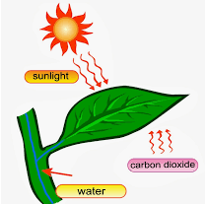

Animals cannot make their own food. They obtain their food from plants and other animals. The food is digested or changed into simpler substances by the action of special juices so that it can be easily absorbed by the body cells and used for various activities or can be stored.
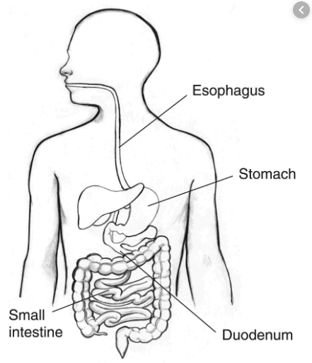 Digestive System in Human.

All living thing breathe:
All living things need energy to perform various activities.
They take in oxygen from their surroundings. This oxygen combines with the food and oxidizes it to release energy. Carbon dioxide gas is produced during this process. This process is called respiration.
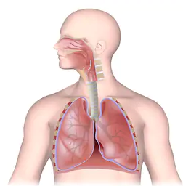 Respiratory System

Green plant breathe through small pores called stomata which are present
under the surface of leaves.

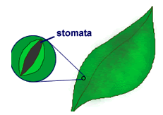Stomata in plant leaves.

All living things get rid of waste matter:
The process by which poisonous materials are removed from the body is
called excretion. Animals usually have special excretory organs such as the lungs
and kidneys.
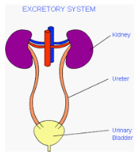 Excretory Organs

Plants do not produce many waste substances. In fact, they reuse waste
matter to make useful substances. Some wastes are stored in old leaves or other parts of the plant which are shed after some time. In plants oxygen, which is produced during respiration, is removed through the stomata.
All living things move:
Living things can move on their own. Animals can move with the help of special parts of their bodies such as arms and legs, fins or wings.
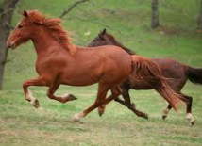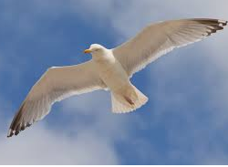

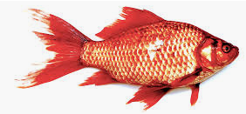

All living things reproduce:
Living things produce living organisms of their own kind. Animals reproduce by producing eggs or babies and plants reproduce by producing spores or seeds in fruits or cones.
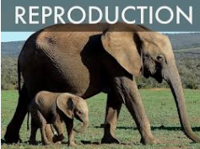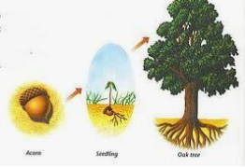

Conditions necessary for living things:
Water:
Three-fourths of the Earth's surface is covered with water in the form of
oceans, and ice caps.
Oxygen:
Most living things need oxygen for respiration, which helps to produce
energy for the various activities of the body.
Light:
Sunlight provides energy for all living things. Plants use sunlight to make food by photosynthesis. Animals get energy indirectly from green plants, either by eating them or by eating animals which eat plants.
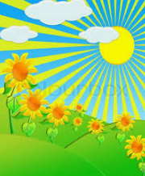

Carbon dioxide:
There is about 0.04 percent carbon dioxide (CO2) in the atmosphere. It is constantly being increased by the respiration and excretion of animals and also by the burning of wood and coal. Plants use carbon dioxide as a raw material for making their food.
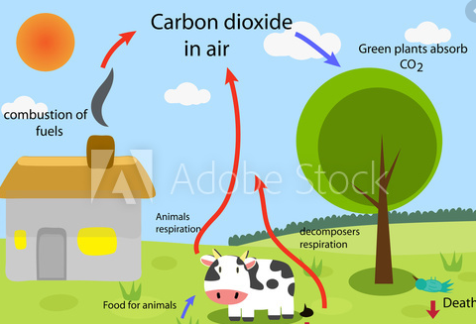

Ecologists:
Ecologists are scientists who study the ways in which living things depend on non–living things like soil, water, sunlight and air.
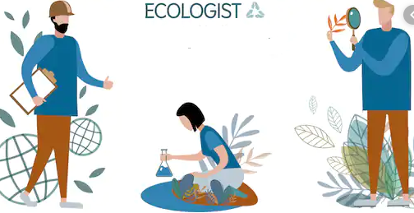

Energy for living things:
All living things need energy. They get their energy from food. Green plants
make their own food. They use sunlight to make food by a process called
Photosynthesis.

Animals and humans cannot make their own food. They obtain energy
from plants by eating them. So animals are called consumers.

Consumers are of different kinds. Animals that eat plants are called herbivores. Rabbits and cows are herbivores. Animals that eat the flesh of herbivores are called carnivores. Lions and tigers are carnivores. Animals that eat both plants and animals are called omnivores. Hens and crows are omnivores, and so are humans.

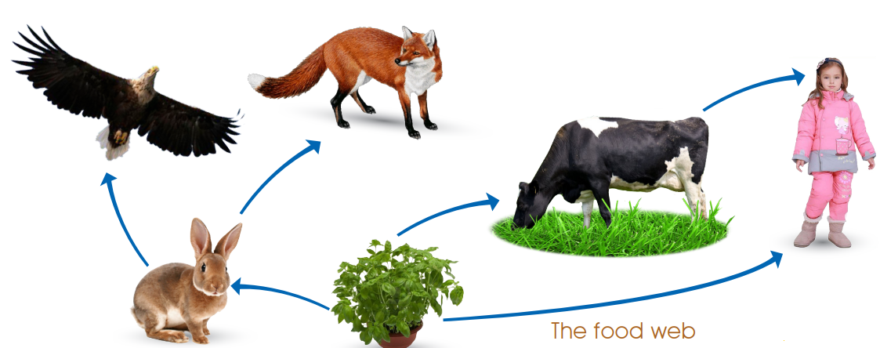

Adaptations:
Every living thing has some features which help it to live a particular environment. Such special features are called adaptations.
An eagle's beak and a lion's teeth are adapted for tearing flesh.

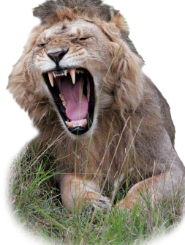
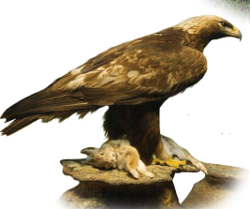

How plants protect themselves:
- Some plants, like the rose and cactus, have thorns or spines
on their stems and leaves.
- Some plants, like the lime and gardenia, have a strong smell.

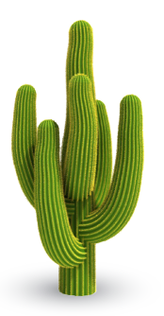

Unite three: Water
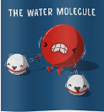
Water is a chemical substance which is found in abundance around us.
Three-fourths of the Earth's surface is covered with water. Water is a combination of oxygen and hydrogen, and its chemical formula is H2O. Water occurs naturally as rainwater, groundwater, river water and sea water.

Water cycle:
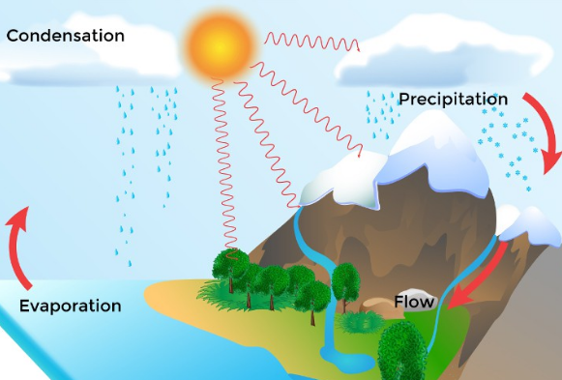

Evaporation: This is when warmth from the sun causes water from oceans, lakes, streams, ice and soils to rise into the air and turn into water vapor Water vapor droplets join together to make clouds!
Condensation: This is when water vapor in the air cools down and turns back into liquid water.
Precipitation: This is when water (in the form of rain, snow, hail or sleet) falls from clouds in the sky.
Flow: This is when water that falls from the clouds as rain, snow, hail or sleet, collects in the oceans, rivers, lakes, streams. Most will infiltrate (soak into) the ground and will collect as underground water.

States of water:
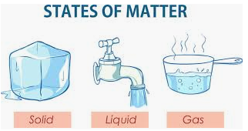
The state of water can be changed by heating or cooling.
Ice changes to water when it is heated or put in a warm place. The temperature at which ice melts is 0 C. It is called the melting point of ice.
When water is heated, its temperature rises. Some of it changes into water vapor. This change is called evaporation. As water gets hotter it begins to evaporate more quickly.

Bubbles begin to appear in the water. This is called boiling. Water vapor forms faster and rises as steam.
The temperature of water when it is boiling is called the boiling point of water. Water boils at 100C.
When steam is cooled, the opposite changes take place.
Steam changes to liquid water. This is called condensation. If it is cooled further, it freezes to form solid ice. This is called freezing.

Purification of water in the laboratory:
Distillation:
Distilled water is the purest form of water.
Water can be purified by a process called distillation. Water is heated in a flask to form steam. The vapor that is produced is cooled to form liquid water.
The vapor is cooled in an apparatus called a Liebig condenser.
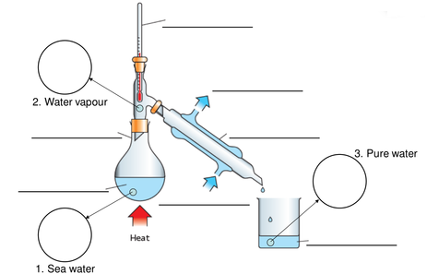

Unite four: Air
The Earth is surrounded by a layer of air which is like a huge ocean. It extends to almost hundreds of kilometers above the surface of the Earth.
Ocean of air is called the atmosphere.
Layers of the atmosphere:
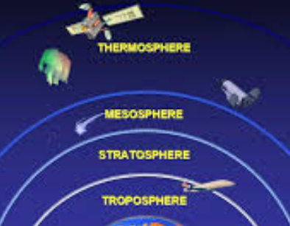

- Thermosphere
- Mesosphere
- Stratosphere
- Troposphere

Atmospheric pressure:
The large mass of air in the atmosphere is heavy and presses down hard on the Earth. Scientists call this weight of the air atmospheric pressure.

Air pressure is greatest at sea level and decreases as we go higher up. It pushes from all sides on everything. Air exerts pressure in all directions at the rate of about 1 Kilogram per cubic centimeter.

Effects of atmospheric pressure:

- Changes in air pressure cause changes in weather. On the surface of the Earth, air always moves from areas of high pressure to areas of low pressure. Temperature has a great effect on air pressure.

- The melting and boiling points of solids, liquids and gases are affected by air pressure. Liquids boil at a lower temperature at higher altitudes because the air pressure decreases as we go from sea level to the top of mountains.
Measuring air pressure:
Air pressure is measured by an instrument called barometer. There are various kinds of barometers.
A simple barometer consists of a long glass tube which is sealed at one end. It is filled with mercury and inverted in a dish containing mercury. The height of the column of mercury in the glass tube measures the atmospheric pressure which is equal to 760 millimeters of mercury at sea level

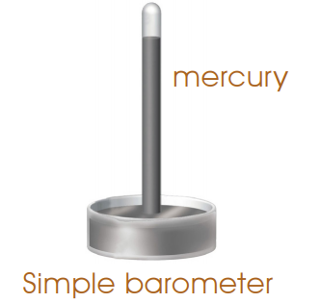
Uses of air pressure:
- To forecast weather with the help of barometers. When the atmospheric pressure in an area is low, air from a region of high pressure comes to fill it. This causes strong windstorms and cyclones.

- To fill medicines in syringes. When a syringe has to be filled with medicine

Air pollution:
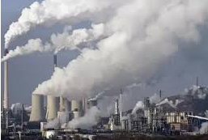

Unwanted and harmful substances in the air cause air pollution.
The main source of air pollution is the burning of coal and oil in houses, factories, power stations and vehicle engines. When burned, they produce soot and smoke and a mixture of poisonous gases.

Unite Five: Pollution

Plants are very important for life on the Earth:

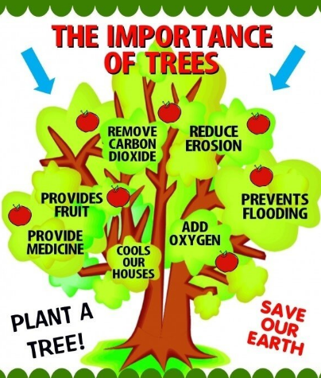

Plants provide food for humans and animals. Plants take in carbon dioxide
gas from the air to make their food. They give out oxygen gas.

Humans and animals breathe in oxygen gas and breathe out carbon dioxide gas.
Trees provide food as well as homes for many animals. When we cut down trees for farming, for making roads and for building houses, these animals lose their shelters and sources of food. Without trees the soil dries up and cracks.

Environment and pollution:
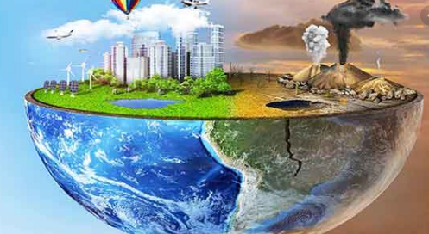

The natural world that surrounds a living thing is called its environment. The environment affects the growth and development of living things.
Humans are making the environment dirty in many ways. When some unwanted and harmful thing appears in an environment we call it pollution.
Anything which harms the environment is called a pollutant.

Water pollution:
When a river originates in the mountains, its water is clean and pure. When it passes alongside a town, chemicals from factories and houses flow into it. Dirty water from houses is called sewage.
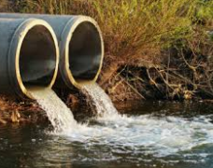

When a river reaches the sea, it is full of poisonous substances.
People bathe and wash in rivers. Animals drink water from them. Polluted water contains chemicals, bacteria and other substances which can make us ill or even cause death.

Oil tankers carry tons of oil. If an oil tanker leaks, it creates an oil spill
in the sea. Oil kills fish, seabirds and other sea animals.
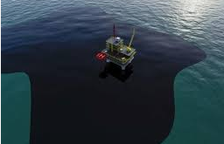

Land pollution:
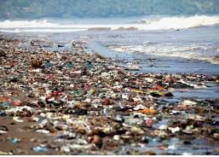
Farmers grow crops to give us the food that we need. By growing more and more crops on the same land for many years the plants use up the important minerals in the soil. The soil cannot grow plants any more.
Farmers use chemicals called weed killers to get rid of unwanted plants called weeds.

How to control pollution:
We can control pollution in the following ways:
- Trees should not be cut down.
- New trees should be planted.
- Crops should not be sprayed with chemicals.
- Fumes from motors and factories should be filtered.
- Waste material and garbage should be buried.
- Waste materials should be recycled (used again).

Unite six: Energy:
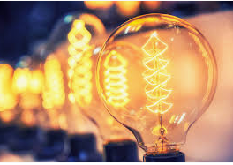
The world is full of movement. People and animals walk about. Ships sail on the sea.
Airplanes fly in the air. All these things cannot move by themselves. They need energy. All the energy on Earth comes from the Sun. The Sun’s energy is called solar energy. It changes into other kinds of energy when it reaches the Earth.

Kinetic energy:
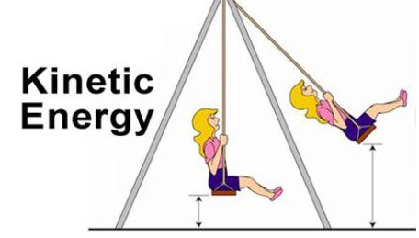
Everything in the world is made up of atoms and molecules.
Atoms and molecules move about or vibrate all the time. Moving atoms have energy called kinetic energy.

Potential energy:
Potential energy is the stored energy of a body due to its position.
A ball put on a high shelf has more potential energy than if it is placed on the
floor. The ball gains extra energy because work is done when the ball was
placed on the shelf.
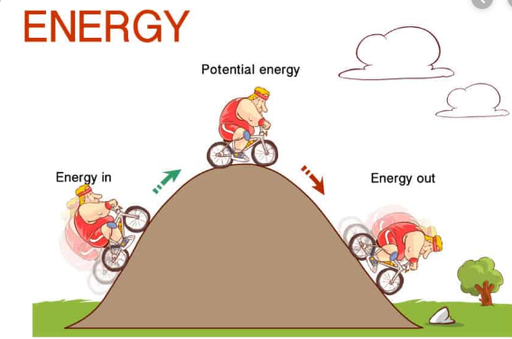
Sound energy:
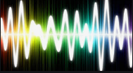
Sound is a kind of energy. When an object vibrates, it makes the air around
it vibrate. The vibrations travel in the air as sound waves.

Chemical energy:
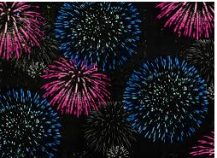
Fireworks are made of gunpowder and other explosive chemicals. These chemicals contain a lot of energy. Fireworks use this chemical energy. When gunpowder burns, it releases large amounts of energy in the form of sound, heat and light.

Nuclear energy:
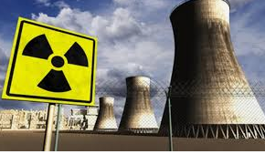
The nucleus of an uranium atom can be split into two. This breaking apart is called fission. When the nucleus of an uranium atom splits, some of its neutrons escape. These neutrons crash into other uranium atoms causing them to split. This splitting of the atom releases huge amounts of heat. This heat is used to produce electricity.

Food energy:
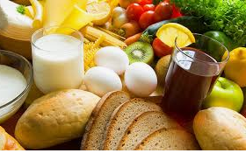
The energy for our body comes from the food we eat. Food contains chemical energy. Energy from food is released only after it has been broken down or digested in the body.

Energy changes:
Every form of energy can change into another form. Coal is a fuel that contains
chemical energy. When coal burns, the chemical energy inside it changes into
heat and light.

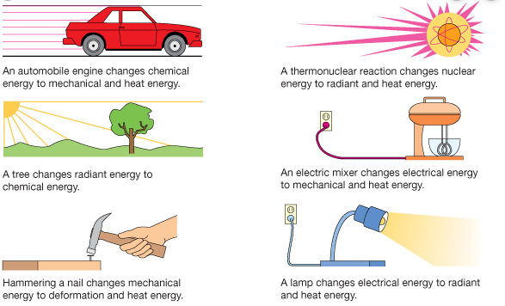

Unite seven: Electricity
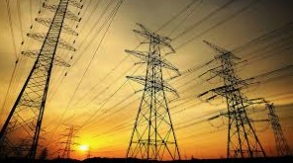
Matter is made up of atoms. Every atom has a nucleus which is surrounded by
spinning electrons. Inside the nucleus there are two kinds of particles - the
protons which have a positive charge and the neutrons which have no charge.
Electrons have a negative charge.
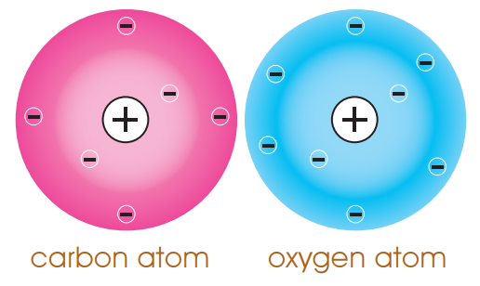
In some materials, the electrons move easily. They can be pushed from atom to atom. As the electrons move, they push other electrons and make those electrons move. This makes the electrons flow in a particular direction.

How electricity is produced:
Electricity is made in a special place called a power plant. The machine
that makes electricity is called a generator.
A generator makes electrical energy, but it uses energy as well. It uses running water, burning fuel or nuclear energy to run the machine inside it to make electricity. It changes other kinds of energy into the electrical energy that we can use.

Electric circuit:
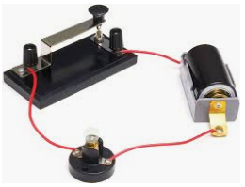
The pathway by which an electric current moves along the wires is called
an electric circuit.

Static electricity:
The effects caused by charged particles collected in one place are called Static
Electricity.
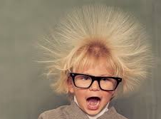

When two objects made of different materials are rubbed against each
other, electrons may be transferred from one to the other. Due to this, the
balance of charges is upset and one object becomes more negatively or
more positively charged than the other.

Lightning:
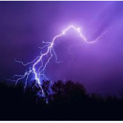
A flash of lightning can be seen in the sky when positive and negative
charges in the clouds jump towards each other through the air. The electric current makes a spark which is seen as a flash.

Unit Eighth: Magnetism
Structure of an atom:
Matter is made up of tiny particles called atoms which are, in turn, made up of small particles called protons, neutrons and electrons.

An atom is made up of a central nucleus which contains positively charged particles called protons and neutral particles called neutrons
Negatively charged particles called electrons spin around the nucleus along definite paths called orbits. The number of protons in the nucleus balance the number of electrons in the orbits and therefore, the atom is a neutral particle.
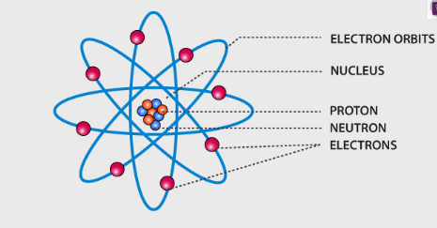

When an atom gains or losses electrons, it becomes charged and is called an ion. When an atom gains electrons, it becomes a negative ion and when an atom loses electrons, it becomes a positive ion.

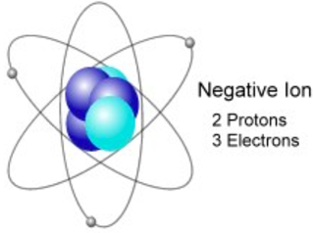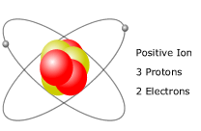
Electrostatic induction:
A positively charged object will attract or pull a negatively charged object
but objects having similar or same charges will repel or push each other.
If a charged object is brought close to a neutral object, it will produce an opposite charge. This process is called induction. Clothes made from man-made fibers, such as nylon, build up charges very quickly when they are rubbed and can even produce sparks.

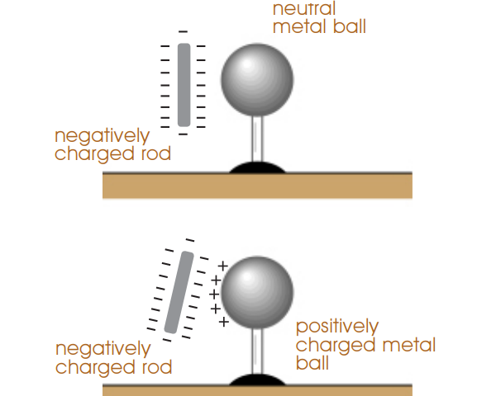

Gold leaf Electroscope:
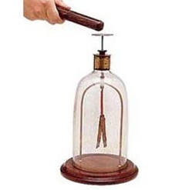
A gold leaf electroscope consists of two gold foil leaves attached to a metal ball by a rod. These are enclosed in a glass case. If a charged body is brought close to the neutral metal ball of the electroscope, the gold leaves repel each other because an opposite charge has been induced in them, and they have a similar charge.

Electrostatic induction in nature:
Clouds become charged when tiny water droplets or crystals of ice present in the clouds rub against each other. When they become highly charged, a large number of electrons jump from one cloud to another or from a cloud to the Earth in the form of a stream. This flow of electrons produces a flash of lightning.

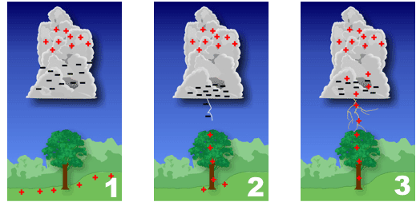

Conductors and insulators:
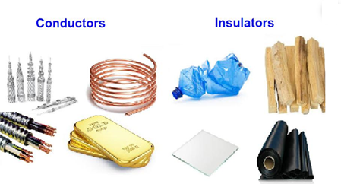

Materials that allow an electric charge to pass along them are called Conductors. Metals are good conductors of electricity.
In Insulators, the electrons are all tightly help to the atoms, so they cannot
move through the material, even when pushed. Plastic, rubber, and wood.

Magnets:
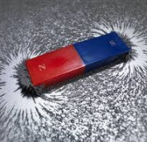
Magnetism is a force which appears between magnets and magnetic materials like steel and iron. For example, a magnet will attract steel pins and iron nails brought near it.

A piece of iron becomes magnetized when it is touched by magnet, which means magnetism has been induced in it. But when it is pulled away from the magnet, it loses its magnetism. This type of magnet is called a temporary magnet.
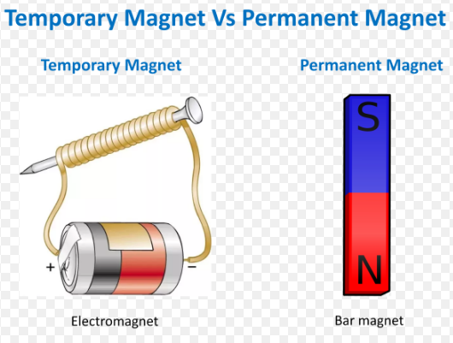
Shapes of Magnates:
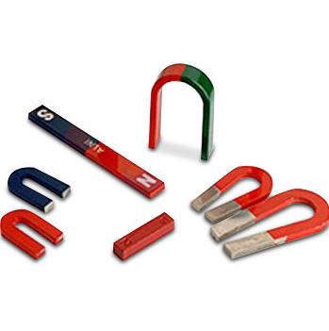
Magnets are of various shapes. They include the bar magnet, horseshoe magnet, rod magnet and U-shaped magnet.

A magnet is a material found in nature which has the power to attract things made of iron, cobalt or nickel. The force with which a magnet attracts such things is called magnetic force. The area around a magnet in which its magnetic force acts is called a magnetic field. The ends of magnet are called poles.
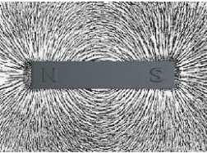 Magnetic field

Types of magnets:
- A simple magnet
- A compass needle
- An electromagnet

Uses of electromagnets:
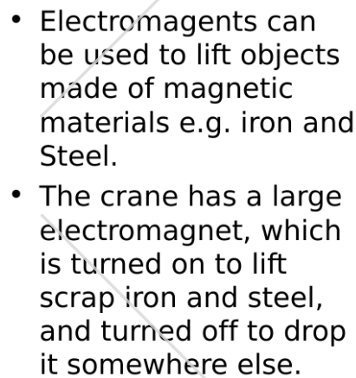

Unite Nine: The Earth
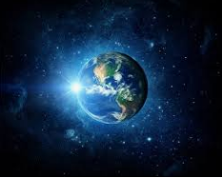
What is the Earth made of?
If a slice of the Earth could be cut out right up to its center, the following
layers would be seen:
Crust:
This is the hard rocky shell around the Earth.
Mantle:
The mantle is the layer of the Earth below the crust. It is made up of very heavy rocks. In the deepest parts of the mantle rocks melt due to the high temperature.
Core:
The core lies below the mantle. It can be divided into two layers.
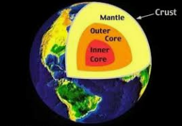

The Moon:
The Moon is the Earth's natural satellite, Its force of gravity is one-sixth of the Earth’s gravity. It has no atmosphere and no signs of life. The Moon rotates very slowly. It rotates once in the same time as it takes to complete one orbit around the Earth.

Lunar eclipse:
When the Earth comes between the Moon and the Sun, we can see the
shadow of the Earth slowly moving across the face of the Moon. This is
called a lunar eclipse.
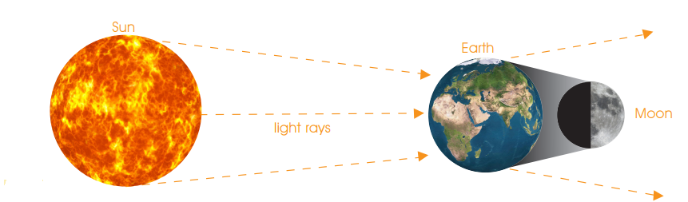

Solar eclipse:
When the Moon comes between the Earth and the Sun, the light from the Sun is hidden and the Moon appears as a black disc on the Sun. This is called a solar eclipse.
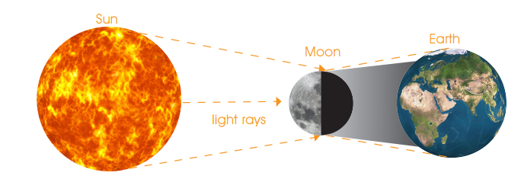

Phases of the Moon:
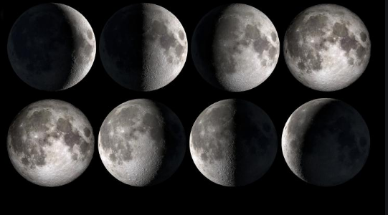
The moon revolves around the Earth once every 29.5 days. This is called
a lunar month. When the side lit by the Sun faces the Earth, we see a full Moon.
When the Moon is on the side of the Earth nearest to the Sun, we see thin slice
of the Moon. This is called a new Moon. Sometimes we see no Moon at all. The
sections of the reflecting surfaces of the Moon are called phases of the Moon.

Day and Night:
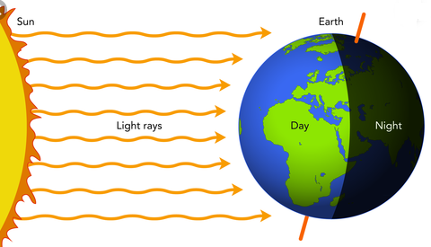

The Earth is constantly spinning. It rotates on an axis through the North and South poles once in 24 hours or a day. This movement of the Earth on i on its axis is called rotation.

The Seasons:
- Earth’s seasons are caused by Earth’s tilt and its orbit around the sun, which results in yearly changes in the amount of sunlight received by Earth’s surface.
- Earth rotates once every 24 hours on an axis that runs between the poles. Earth also orbits the sun once every 365 days. Relative to the path of Earth’s orbit, Earth’s axis is tilted by 23.5°—globes are tilted to model this. As Earth orbits the sun each year, the axis is tilted either toward or away from the sun.

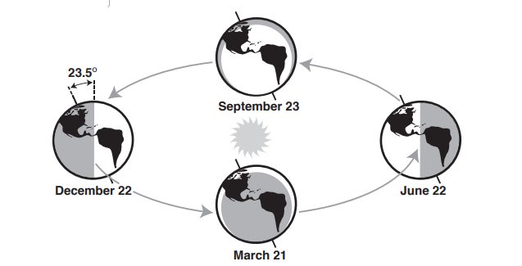

Unit Ten: The Atmosphere and Weather:
What the air is made of:
The air around the Earth is made up of a number of different gases, which are invisible. We cannot see them. Nitrogen and oxygen are the two important gases in air. There are many particles in air including dirt, sand, smoke and salt.
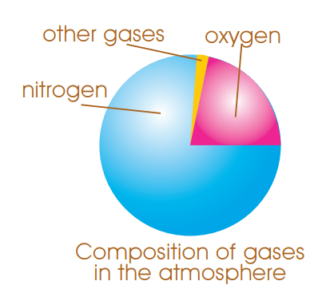

The atmosphere protects the Earth from becoming too hot:
When rays from the Sun reach the Earth, they meet the air. They also meet clouds and particles. Some of the rays are reflected back into space and some are absorbed by the clouds and dust particles. Some of the rays pass through and heat the surface of the Earth. The air around the Earth is never still. It is moving nearly all the time. Air which moves is called wind.

Air moves from areas of high pressure to areas of low pressure.On sunny summer days, the land gets warmer than the water. The air near the land warms up and raises. The air pressure over the land lower than over the water, and air moves in from the sea. This is called a sea breeze.
At night, the land cools down quickly, but the water remains warm. The air above the water becomes warm and rises. The air pressure over the water is lower than over the land. The air move from the land to the sea. This is called a land breeze.
In this way, air circulates between the sea and the land.
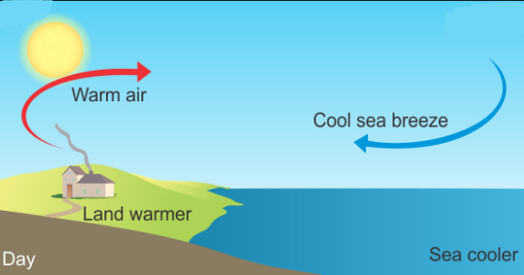

Monsoon winds:
Summer monsoons:
In summer the land warms up more quickly than the sea. A large low pressure area forms over the land. Cool air from the sea blow towards the land. As the sea air is moist, it often brings rain.
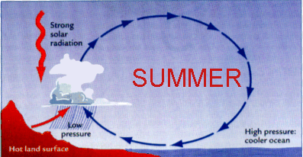

Winter monsoons:
During winter the opposite happens. The air over the land becomes cold and forms a high pressure area. Air from the continents moves out over the sea. As it blows from the land towards the sea, it does not bring rain.
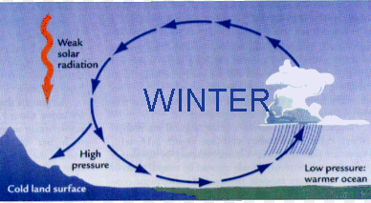

Atmosphere, clouds and rain:
Clouds are formed in the air. When the Sun shines on the surface of water, it changes the water into invisible water vapor. Water vapor rises and begins to cool. As it cools, it changes into tiny droplets of water called cloud droplets.
When air blows against a mountain, it is pushed up. There it cools down
and the cloud droplets mix tighter to from a cloud.
Cloud droplets keep moving. They bump into each other and become larger and heavier. Finally, when they cannot stay afloat any longer, they fall to the ground as rain.

Unite 11: Space, Stars and Plants
Space is the area beyond the earth's atmosphere. It starts from where the atmosphere of the Earth fades away.
There is no air in space. It is full of dangerous rays and particles which are moving very fast.
Nebulae:
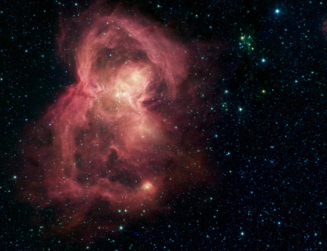

There are great clouds of gas and dust in space. These clouds are called nebulae.
An island of stars spinning through space is called a galaxy. Our Earth is in
the Milky Way Galaxy. There are many other galaxies in space.

The Solar System:
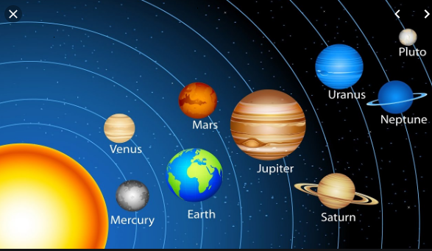

Bodies that go around the Sun are called planets. They go round the Sun
in fixed paths called orbits. Planets have other smaller bodies going around them. They are called moons. The Earth has one Moon, Jupiter has four and Saturn has eighteen moons. The Sun and all the planets and moons make up the Solar System.
There are eight planets in the Solar System.
They are Mercury, Venus, Earth, Mars, Jupiter, Saturn, Uranus and Neptune.

Asteroids:
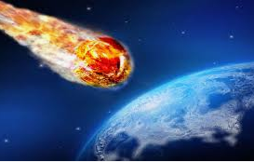
An asteroid is a lump of rocky material in space; they are going around the Sun in their own orbits like small planets.

Comets:
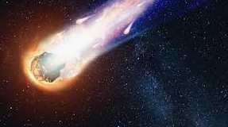
These are wandering lumps of ice and dust in space. They have a large glowing head and a tail of gas and dust.

The Sun:
The Sun is a star in our Solar System. It is 330 000 times bigger than the Earth. Its diameter is 1 384 000 kilometers. The distance between the Earth and the Sun is about 149 million kilometers.
The Sun is made of gas and dust. The temperature in the center of the Sun is 14 000 0000C. The temperature on the surface of the Sun is 6000 C.

Planets of the Solar System: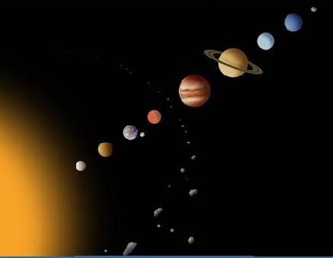
- Mercury
- Venus
- Earth
- Mars
- Jupiter
- Saturn
- Uranus
- Neptune.

