**Every Day Science**

**Grade 5**

**Unit One: Reproduction in Living Things:**

**Reproduction in animals:**

Living things make new living things of their own kind. This is called **reproduction**. Some animals lay eggs and some give birth to babies.

Animals like dogs, cats cows and sheep have babies. They feed them on milk which is produced in the mother's body. They look after their young ones till they are strong enough to feed and look after themselves.

**Reproduction in Fish:**

In most fish, the female lays eggs in bunches in the water. Baby fish begin to swim about and feed as soon as they hatch.

The male fish looks after the eggs for seven to ten days. When the eggs hatch, the young fry are kept in the nest for a month. Then the young fish leave the nest and begin to swim and feed freely.

**Reproduction in Birds:**

Most birds build nests, in which the female lays two to four eggs.

The female sits on the eggs and keeps them warm.

In one or two weeks, the eggs hatch into baby chicks. They are covered with small feathers and their eyelids are closed. Both parents feed and look after the baby birds till they are strong enough to fly and find their own food.

In humans and other mammals, the female gives birth to babies. As soon as baby is born, it begins to feed on its mother's milk. Both parents look after the baby.

When the young animals are strong enough to find their own food, they leave their parents.

**Reproduction in plants:**

**The Structure of Flower**:

## The Female Reproductive Organ: The Carpel

The female parts of a flower consist of an **ovary**, a **style** and the **stigma**. The ovary is at the base of the flower. From the ovary, extends a tubular structure called the style and on the top of the style is a surface receptive to pollen called the **stigma**, after fertilization the ovule becomes the seed and the ovary becomes the fruit.

## The Male Reproductive Organ: The Stamen

The male parts of a flower consist of one or more **stamens**. Each stamen is made up of paired **anthers** (sacs containing pollen) on a filament or stalk. The anthers are the orange/yellow structures often seen in the center of a flower.

Pollen from the anthers of one flower is transferred to the stigma of another usually either by wind, or by animals, especially insects.

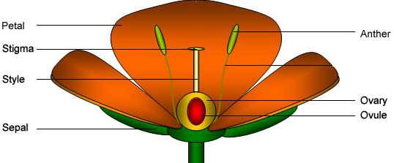

**Pollination:** Brightly-colored flowers, with sweet smells and nectar, attract insects such as bees and butterflies. These insects suck the nectar. When an insect sits on a flower, the pollen sticks to its wings and legs. When it sits on another flower, the pollen from its body sticks to the stigma of that flower, when the pollen of a flower taken to the stigma of another flower.

**Structure of a seed:**

A seed has a hard outer coat called the **testa**. It protects the seed. There is a small hole in the testa through which air and water enter the seed.

There is a tiny plant inside the seed. It is called an **embryo**.

A seed also has one or two seed leaves or cotyledons.

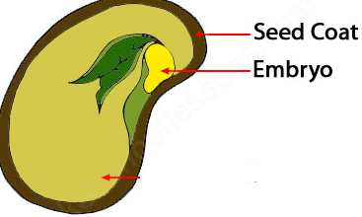

**Unit two: Food and Diet**

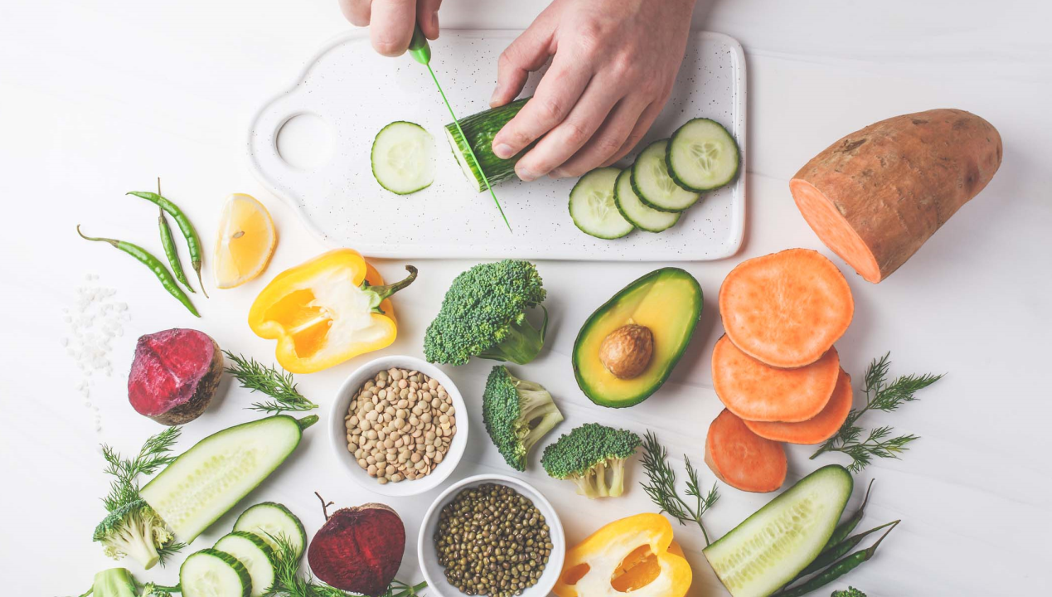

All living things need food. Food gives energy to the body. Food is needed

for the growth of new cells and the repair of the damaged parts We need food to stay healthy.

**Food of plants:**  Most green plants make their own food from materials that are taken from the air and soil.

Plants take carbon dioxide gas from the air and water and mineral salts from the soil. They make simple sugars such as glucose.

**Storage of food in plants:**

Extra food that is made in the leaves of a plant is stored in some parts.

Food can be stored in underground roots, as in the carrot

**Foods in Animals:**

Animals feed on living organisms such as plants and other animals.

Food is a mixture of substances. These substances are proteins, carbohydrates, fats, vitamins, minerals, fiber, and water.

**Carbohydrates:**

Carbohydrates give us energy. Sweets, fruits; jam, bread, potatoes, and rice have carbohydrates.

**Proteins:**

Proteins are used for the growth of the body. They help to make new cells.

Meat, eggs, fish, and beans contain proteins.

**Fats and oils:** Fats and oils give us energy. They can be stored in the body. Milk, butter,

Cheese and eggs have fats in them.

**Unit Three: A Healthy Body:**

**To stay healthy:**

You must eat a balanced diet for the proper growth of the body. You must exercise

daily to keep all the parts of the body in good working order.

You must rest to get back the energy that you have used up.

You must wash and keep yourself clean so that you do not catch any disease or become sick.

**Healthy eating:**

You need food to keep alive and stay healthy. Growing children need a lot of proteins. Proteins are found in meat, milk, eggs, fish, and beans.

Fresh fruits and vegetables are also very beneficial.

**Exercising:** Regular exercise keeps your body strong and fit. It keeps your muscles and joints healthy.

**Keeping clean:**

You must keep your body clean. Washing and bathing keeps your body

free from dirt. It also stops you from getting skin diseases.

Your house should not be dirty. The bathroom and kitchen should be especially clean. The rubbish of the house should be kept in a covered bin.

**How do you become ill?**

You become ill when you catch a disease from someone or something.

Many diseases are caused by tiny living things. We call them germs.

Bacteria and viruses are germs. When germs attack the body, we become ill.

**Bacteria:** Bacteria are so small that we cannot see them. We can only see them through

a microscope. Bacteria cause diseases such as cholera.

**Viruses:**

Viruses are very small. They are much smaller than bacteria. They live inside the cells of our bodies. They cause diseases such as the common cold, influenza.

**Vaccinations:**

Doctors can also help your body to fight against some disease germs.

A tiny bit of a germ is injected into your body through a needle. The white blood cells of your body prepare to fight against it. In this way, the body is ready to fight more germs of the same kind. The body becomes immune to that particular germ. This injection is called a vaccination.

**Unit 4: Atoms and Molecules**

**Matter:**All things in the world have weight, and they take up space. Anything which takes up space and has weight is called matter.

**Atoms and molecules:**Matter is made up of tiny particlescalled **atom**. Atoms join up to form molecules.

Water is a simple molecule consisting of one **oxygen** [atom](https://www.ck12.org/c/physical-science/atom?referrer=crossref) bonded to two different **hydrogen** atoms.

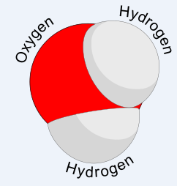

An atom is a tiny particle which has a nucleus in the center. The nucleus is made up of particles called protons and neutrons.

**Structure of the Atom:**

Around the nucleus there are much smaller, lighter particles called electrons.

The number of **protons** and **electrons** is equal.

An atom is like the Solar System in the center, the nucleus is like the sun and the electrons are like planets revolving around it.

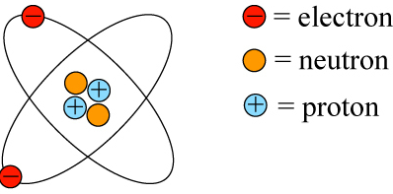

**Kinds of atoms:**

There are many different kinds of atoms.

A substance which has the same kind of atoms is called an **element**.

An element is a simple chemical substance. Carbon, silver, gold, iron and oxygen are elements.

Substances which have atoms of more than one kind are called **compounds**.

Water is compound which is made up of two kinds of atoms: hydrogen and oxygen.

**Matter can change its state:**Substances remain solid, liquid or gas at a certain temperature. If they are heated or cooled, they can change form. When ice is heated, it changes to liquid or water. When water is heated, it changes to gas or water vapor. Molecules of matter are always moving.

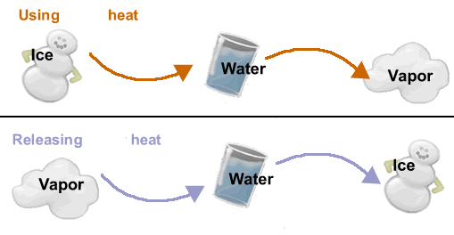

**How a change of state occurs:**

**Melting:** The temperature at which a solid changes into a liquid is called its melting point.

**Boiling:** When water is heated, it begins to boil. The temperature at which a liquid boils is called its **boiling point.**

**Evaporation:** Change of a liquid into a gas is called evaporation.

**Condensation:**

Change of water vapor (or gas) into liquid is called condensation.

**Unite five: Water**

**States of water:**  Water is found in its natural state in three different forms.

The water that we drink is the liquid form of water. lce is solid water.

Water vapor is present in the air. It is the gas form of water we cannot see it.

**Impurities in water:**

Natural water is found in the form of rain; spring, well, sea and river water. All

forms of natural water contain suspended particles of sand, mud and clay.

They also contain mineral salts and gases. Natural water found close to cities

and farms contains harmful chemicals and germs.

**Rainwater:**

As rain falls through the air many gases such as oxygen, carbon dioxide and

Nitrogen are dissolved in it. It also brings with it dust and bacteria from the air.

**River water :**

People living in towns and cities use lots of water. Water in our homes comes

from huge stores of water called reservoirs. The water in a reservoir is drawn

from a nearby river. It contains harmful substances, so it has to be cleaned in

a water filtration plant.

Natural water is found in the form of rain, spring, well, sea and river water. All forms of natural water contain suspended particles of sand, mud and clay.

They also contain mineral salts and gases. Natural water found close to cities

and farms contains harmful chemicals and germs.

**Sea Water:**

Sea water has the highest amount of dissolved and suspended impurities.

All the impurities brought by rivers are poured into the sea. Sea water usually contains a lot of common salt or sodium chloride. It also contains salts of calcium, magnesium and iodine. It is not fit for drinking.

**Drinking water:**

Pure water has no taste. Fresh water contains salts and dissolved gases such

as oxygen and carbon dioxide, which give it a pleasant, refreshing taste.

**Unite six: Energy**

There are many different forms of energy.

a) Mechanical energy.

b) Chemical energy.

c) Heat energy.

d) Electrical energy.

e) Light energy.

f) Atomic energy.

(g) Sound energy.

**Mechanical energy:**

The energy that turns the sails of a windmill comes from the wind. Boats

too use wind energy to sail in the sea.

**Chemical energy:**

The energy that makes a car move or an airplane fly comes from petrol. Petrol comes from oil, which provides the energy for most of the world's transport.

**Heat energy:**

Heat energy is given off by anything that burns. Fuels like coal, wood oil and gas give off a lot of heat energy. Heat helps us to do many things. and gas give off a lot of heat energy. Heat helps us to do many things. It is used for cooking and heating our houses. It is used in power stations to make electricity.

**Electrical energy:**  The energy that makes electric lights shine comes from a power station.

**Light energy:**

All energy comes from the Sun. The Sun's energy changes into other kinds

of energy when it reaches the Earth. The Sun provides energy to green

plants for making food.

**Sound energy:**  Sound is a type of energy. Sound waves are produced by the vibrations

made by a moving object. Sound waves make sound energy. A jet engine

makes a lot of sound energy.

**Sources of energy:**

Energy from the Sun is called solar energy. Candles and oil lamps give off

light when they are burnt. Natural gas gives off heat energy when burnt.

We use this energy for heating and cooking.

**Kinetic energy:** As you have learnt earlier, atoms are tiny bits of matter that join together to

make everything in the world. Atoms can form groups called molecules.

Atoms and molecules move about all the time. They have energy called

kinetic energy.

**Energy changes:**

One form of energy can change into another form of energy. Coal is a fuel that contains chemical energy.

When coal burns, the chemical energy inside it changes into heat energy.

In a power station, the chemical energy of the fuel is changed into electrical energy. Electrical energy can be changed into heat energy, as in a heater. It can also be changed into light energy, as in electric lamps

and bulbs.

**Storing energy:**

Energy can be stored. When we wind a clock, the coiled spring inside it stores energy. This energy is called potential energy. It changes into kinetic energy as the spring unwinds.

It turns the hands of the clock. Animals store energy in their bodies as fats. It helps to keep them warm during cold weather.

Electrical energy can be stored in batteries as chemical energy. When a car is moving, the kinetic energy produced by its engine is changed into electrical energy which is stored in the battery as chemical energy.

**Uses of energy:**

**Burning:**  The things needed to make something burn is: fuel, oxygen and heat. If we do not have anyone of these three things, the object will not burn.

**Unit seven: Simple machines**

**Machines need energy:**  All machines need energy to turn the moving parts inside them. Energy helps the machine to do useful work. All machines need a steady supply of energy to keep them working.

**Simple machines:**

You are using a simple machine when you cut paper with a pair of scissor, use a spoon to lift the lid of a tin can, or cut an apple with a knife.

A simple machine helps to make your work easier. It can turn the force of your hand into some kind of movement which helps you to do work.

**Kinds of simple machines:**

**Lever:**

The spoon is a kind of simple machine which is called a lever.

**Wheel and axle:**

Most machines are made up of wheels. A car and a train move on wheels. A sewing machine has a wheel which turns other parts of the machine.

A clock also has wheels of many different sizes. A wheel turns on a rod called an axle. A wheel and axle is a simple machine.

**Pulley:**

A pulley is a simple machine which is made up of wheels. The wheel of a pulley turns on an axle.

There is a groove around the rim of the pulley which holds a rope.

When the rope is pulled, the pulley lifts the heavy load.

**Unit eight: Light**

If you touch the bulb, it is hot. When the light is on, electricity runs through a tiny wire inside the bulb.

This makes the wire get hot. The electrons in the wire absorb energy.

When they are loaded with energy, they throw it off.

These bundles of energy, thrown off by the electrons, are light. The bundles

of energy are called **photons**.

**Moonlight:**

Objects like the Sun, a burning candle, fire or an electric light give off light.

They are called **luminous bodies**. Things such as the Moon, which do not give off light but only reflect the light falling on them, are called **non-luminous** bodies.

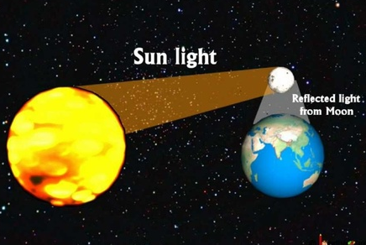

**White light is a mixture of colors:**  When a narrow beam of white light passes through a prism, it splits into all

the colors of the rainbow. The range of colors is called a **spectrum**.

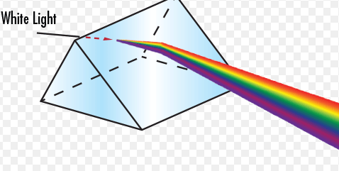

Red, blue and green are called primary colors. These three primary colors are used to make all the other colors. If we mix primary colors, we get secondary colors.

**Light can pass through some materials:**

Materials that allow light to pass through them are called **transparent materials**.

We can see things through them clearly. Air, water and glass are transparent.

Some materials allow light to pass through them, but objects cannot be seen clearly through them. They allow transparent material translucent material Opaque material

only some light to pass through them. These materials are called **translucent**. Frosted glass, waxed paper, clouds and tracing paper are translucent.

**Unit Nine: Magnetism**

**Magnetic field:**

The area around a magnet where the force of magnet can be felt is called its magnetic field.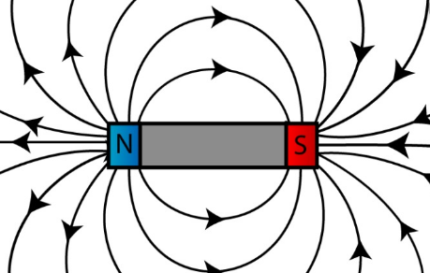

**Types of magnets:** Magnets are of two types:

**Permanent magnets**: An object that is made of hard steel will remain a magnet for a long time Such a magnet is called a permanent magnet.

**Temporary magnets:**

An object that is made of soft iron loses its magnetism after some time. Such a magnet is called a temporary magnet.

**Electromagnets:**

A wire made into a coil will become a magnet when an electric current flows through it. It will have a magnetic field like that of a bar magnet.

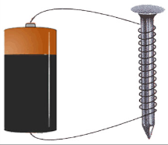

If the electric current is switched off, no pins will stick to it. Such a magnet is called an electromagnet. An electromagnet is a temporary magnet. It behaves like a magnet only when an electric current is flowing through it.

**Demagnetizing a magnet:**

**By heating:** Heat a magnetized needle till it becomes red hot. Cool it and try to pick up pins with it. You will see that it has lost its magnetism.

**By striking or beating:**

Take a magnetized needle and beat it with a hammer or strike it repeatedly

against a solid object. Try to pick up pins with it. You will see that has lost

its magnetism.

**Compass:**

A compass is a small instrument that helps us to find directions.

It has a small bar magnet in the center which always points to the north of the Earth's magnetic field.

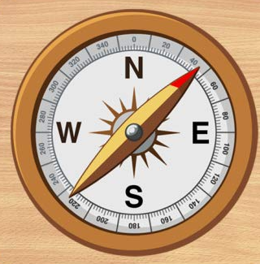

**The Earth's magnet:**

The Earth seems to have a huge magnet inside it. It has magnetic poles

at the ends just like a bar magnet.

**Uses of magnets:**

Electromagnets are used to separate iron and steel objects from non- magnetic objects in a scrapyard. They are also used to move heavy metals from one place to another. Disc magnets are used in telephones and loudspeakers.

**Unit Ten: Sound**

Things which produce sound make the air shake back and forth very fast.

This shaking movement is called **vibrations**. When the vibration air makes our eardrums vibrate, we hear sounds.

A sound vibration makes tiny particles of the air bump into each other. When this happens, the molecules are first pressed together, and then they spread apart or expand again. These molecules pass their energy to the molecules next to them. In this way vibrations are passed from molecule to molecule.We call this a **sound wave**.

**Speed of sound:** Sound waves can travel through doors and walls. You can hear the ticking of a clock if you hold it between your teeth. You can also hear sounds in the water when you are swimming under water.

**Kinds of sounds:**

If we like a sound we call it **musical**. Sounds which we find unpleasant are called **noise**. Musical sounds and noise are made by a number of different vibrations reaching our ears at the same time.

**Reflection of sound:**

**Echo:**

When sound waves hit a barrier such as a cliff, they bounce back, and we

can hear the sound again. This reflected sound is called an **echo**.

**Echolocation:**

Bats make high squeaking sounds and use their ears to pick up the echoes from objects

around them. This is called **echolocation.** It helps bats to find their way in the dark

and to catch food such as flying insects.

**Unit 11: The Earths Movements**

The Earth's crust is always moving. In some places it is rising while in others

it is sinking. These changes usually take place slowly, but sometimes they are sudden such as during volcanic eruptions or earthquakes

There are two types of Earth movements:

a) folding

b) faulting

**Folding** in the Earth's crust is caused by the pushing of two forces towards

each other. The rocks that lie between them fold upwards or downwards forming mountains or ridges.

Sometimes the rocks crack or fault and from block mountains and rift valleys between them.

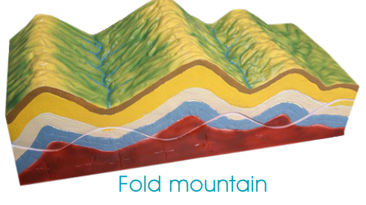

**Weathering and erosion:**

Rocks are hard and solid, but they can be broken down by a process called **weathering**. The process by which sand, soil and rocks move from one place

to anther is called **erosion**.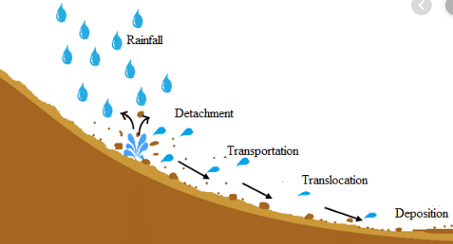

Small pieces of rock that are washed or blown away are called **sediment**. The sediment settles down in some other place in the form of layers. These layers are pressed together to make new rocks, called **sedimentary rocks**.

**The soil:** The small pieces of rock that are formed by weathering make up a large part of the soil. The soil has particles of different shapes and sizes.

**Soil erosion**:

Soil erosion means the loss of soil from the land. The roots of plants help to hold surface of the soil to together. If plants and trees are removed from the soil by fire or by too much animal grazing on grasslands, soil erosion takes place.

**How soil erosion can be controlled:** a) Trees should be planted on steep slopes.

b) Grass should be planted on slopes.

c) Sloping fields should be cut into testacies.

**Unite 12: Oceans**

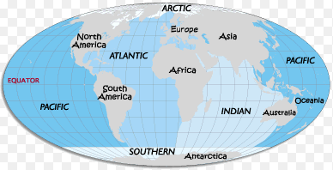

Three-fourths of the Earth's surface is covered by water. Most of the water is

Found in huge bodies of water called **oceans**.

There are five oceans in the world. The oceans, according to their size, are:

1. Atlantic Ocean
2. Southern Ocean
3. Indian Ocean
4. Pacific Ocean
5. Arctic Ocean

**How oceans were formed:**

Some scientists believe that oceans were formed 4,000 million years ago, when rain filled the low places in the Earth's crust.

The land under the oceans is made up of flat planets, valleys and mountains. It even has volcanoes.