**Student Name: ___________________ Date: / /   
  
Unit: 3   
  
  
1. Write the name of each plant under each picture.**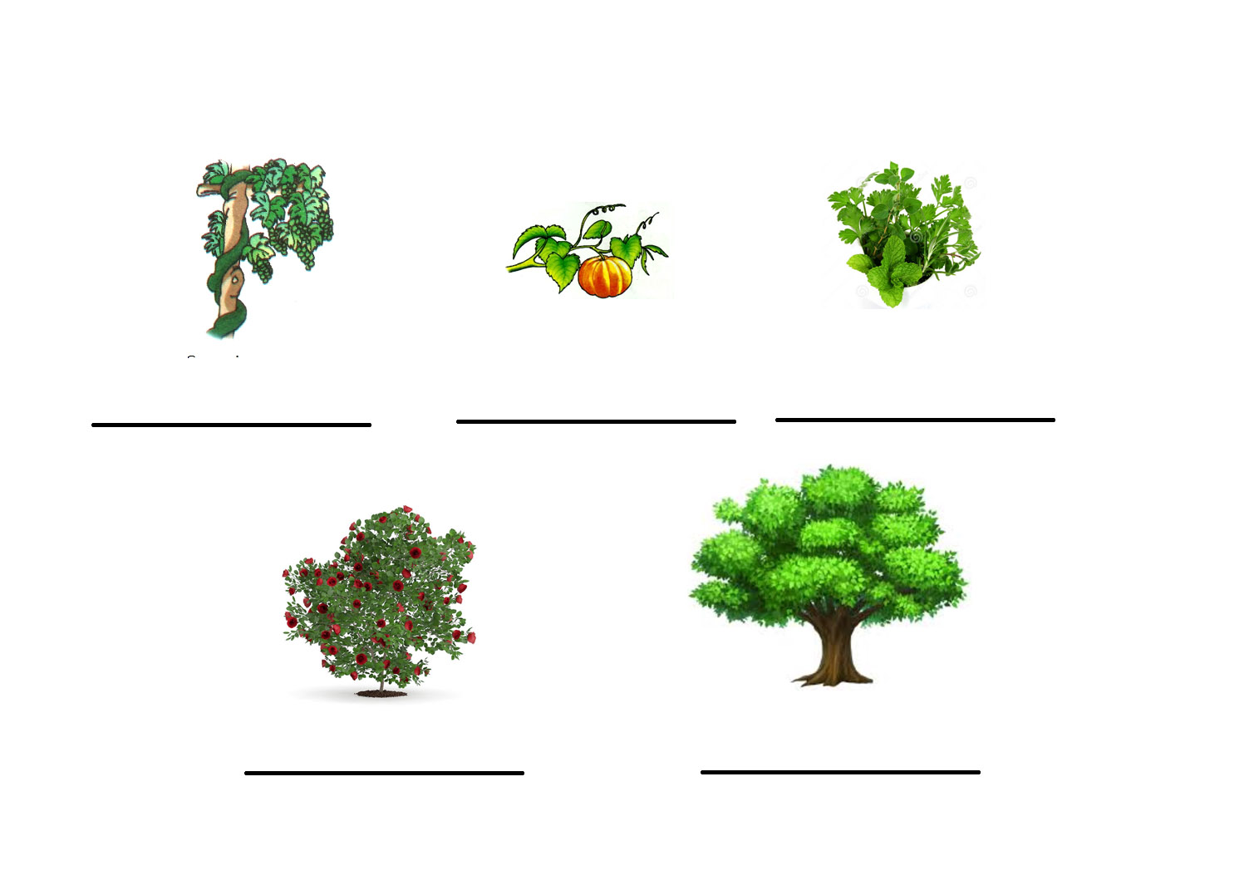  
2. Mention the main part of each kind of plants.