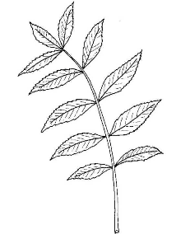**UNITS 3: PLANTS**

1. **Fill in blanks with the correct answer.**
2. Plants need _________and _________to make food.
3. Green plants have _________in their leaves.
4. Mention two plants that make spores.
5. _________________________
6. _________________________
7. Seeds are made inside __________________
8. **Write the parts of the flower**.

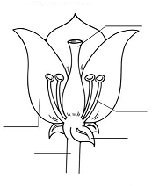

1. **Draw a Pine cone**

|  |
| --- |
|  |

1. **Read the statements below. Decide whether they are true or false.**

|  |  |  |
| --- | --- | --- |
| Statement | True | False |
| 1. Some plants do not have flowers**.** |  |  |
| 1. Some plants do not make fruits or seed. |  |  |
| 1. Spores can grow and make new plants. |  |  |
| 1. Rose is a plant that makes spores. |  |  |
| 1. Pollen cones can make seeds. |  |  |
| 1. Pine trees can make cones. |  |  |

1. There are two types of cones made by pine trees. Mention two.
2. ______________________
3. ______________________