**UNITS (10 +11): The Sun and Stars/ the Moon**

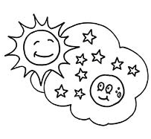

1. **Fill in blanks.**
2. Stars are very…….
3. Stars give off ……..
4. Plants use Sunlight to make their ……..
5. Sunlight helps our skin to make **………..**
6. The Moon has deep holes which are called……..
7. The Moon is …………kilometers away from earth.
8. **Draw the names of the three shapes of the Moon.**

|  |  |  |
| --- | --- | --- |
| **Full Moon** | **Half Moon** | **Crescent Moon** |