**UNIT 1: Growth and movement in living Things**:

1. **Answer the following Questions**.
2. **Write five things that living things can do**?

1-

2-

3-

4-

5-

1. **Label the following** :

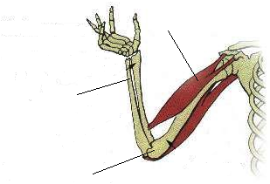



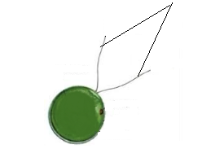

1. **Fill in blanks to complete the statements**
2. Fish have ……..to swim in water.
3. Birds and insects have ………to fly.
4. Sharks have………………to swim.
5. The point where two bones are fitted together is called……..
6. The framework of bones is called a ………………
7. The hard outer covering in ants called…………….
8. Chlamydomonas have ………..which helps them where the sunlight is.
9. Euglena can swim towards the light by a hair like structure called the ……………
10. The sunflower turns its face toward………
11. Cattle and sheep give us ………and …………….
12. A………….is the swollen part of potato stem which has a lot of stored plant food.
13. A bud can grow into new branches or……………….
14. Honey bees give us ………., they also pollinate ………
15. **Name the picture with the correct stage of the frog life cycle:**

