SPECTRUM of LIGHT

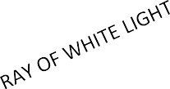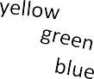

red

orange

GLASS PRISM

Refraction: the colours separate because different wavelengths of light have different angles of refraction.