**Students name:………………………. Date: / /   
Unit 5: Heat and light**   
  
**1. True or false**  
   
A. We can see in dark …………   
B. Light can pass through wood ………...  
C. We don't need heat to cook ………….  
D. We need heat to keep us warm in winter. ………….  
  
**2. Fill in the blanks**   
  
A. We can get heat from burning things like …………..   
B. ……….. is the main source of energy.  
C. ……….. is used when a solid melts into a liquid.  
  
**3. Color this paint.**   
 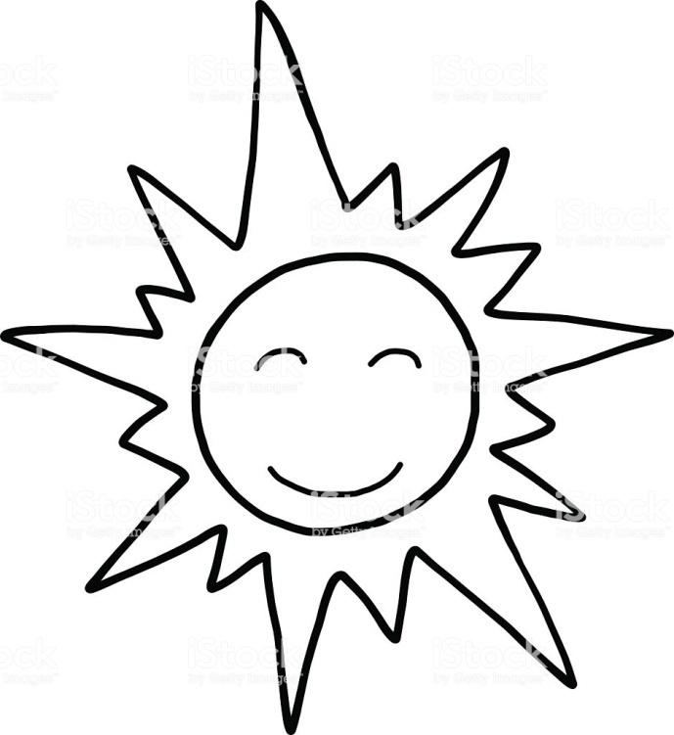  
  
  
  
  
Useful link (https://youtu.be/d7yTlp4gBTI)