**Who Am I?**

**Part 1: Fill in the blanks with your information:**

1. My name is ______________________.
2. I am ______________________years old.
3. I am in the ______________________grade.
4. I live in ______________________.
5. I come from ______________________.

**Part 2: My Body**

**B. Draw a picture of yourself in the box below.**

*Draw your face, hair, and eyes.*

**Part 3: Healthy Habits**

**C. Circle the correct answer:**

1. I brush my teeth (one / two) times a day.
2. I wash my hands to kill (germs / toys).
3. I eat (candy / fruits) to stay healthy.

**Part 4: My Family**

**D. Draw a heart around the people in your family.**

* Mother
* Father
* Sister
* Brother
* Grandparents

**Part 5: Friends**

**E. Describe your friend using the words below:**

*Black hair, brown hair, blue eyes, green eyes*

"My friend has ______________________ hair and ______________________ eyes."

**Part 6: Vocabulary**

**F. Match the word with its meaning:**

1. Family Someone you like to play with
2. Healthy People you love and live with
3. Friend Feeling good and strong

**My Health**

**A. Fill in the blanks:**

1. I take a __________ every day. *(Hint: a way to clean your body)*
2. I brush my __________ twice a day. *(Hint: What do you clean after eating?)*
3. I wash my __________ before eating. *(Hint: What do you use to touch things?)*
4. I wear __________ clothes every day. *(Hint: What do you put on to stay clean?)*

**Part 2: Healthy Foods**

**B. Circle the healthy foods:**

1. **Fruits**  
   🍎 🍰 🍊 🍔 🍌
2. **Vegetables**  
   🥕 🍟 🍅 🍕 🥒
3. **Drinks**  
   🧃 🥛 🍿 🥤 🍪

**Part 3: Exercise**

**C. Look at the pictures below. Circle what makes you strong and healthy:**

1. 🛏️ (Sleeping all day)  
   🏃 (Running and playing outside)
2. 📺 (Watching TV all day)  
   🚴 (Riding a bike)
3. 🍬 (Eating lots of candy)  
   🍎 (Eating fruits and vegetables)

**Part 4: Good Habits**

**D. Match the healthy habit with its picture:**

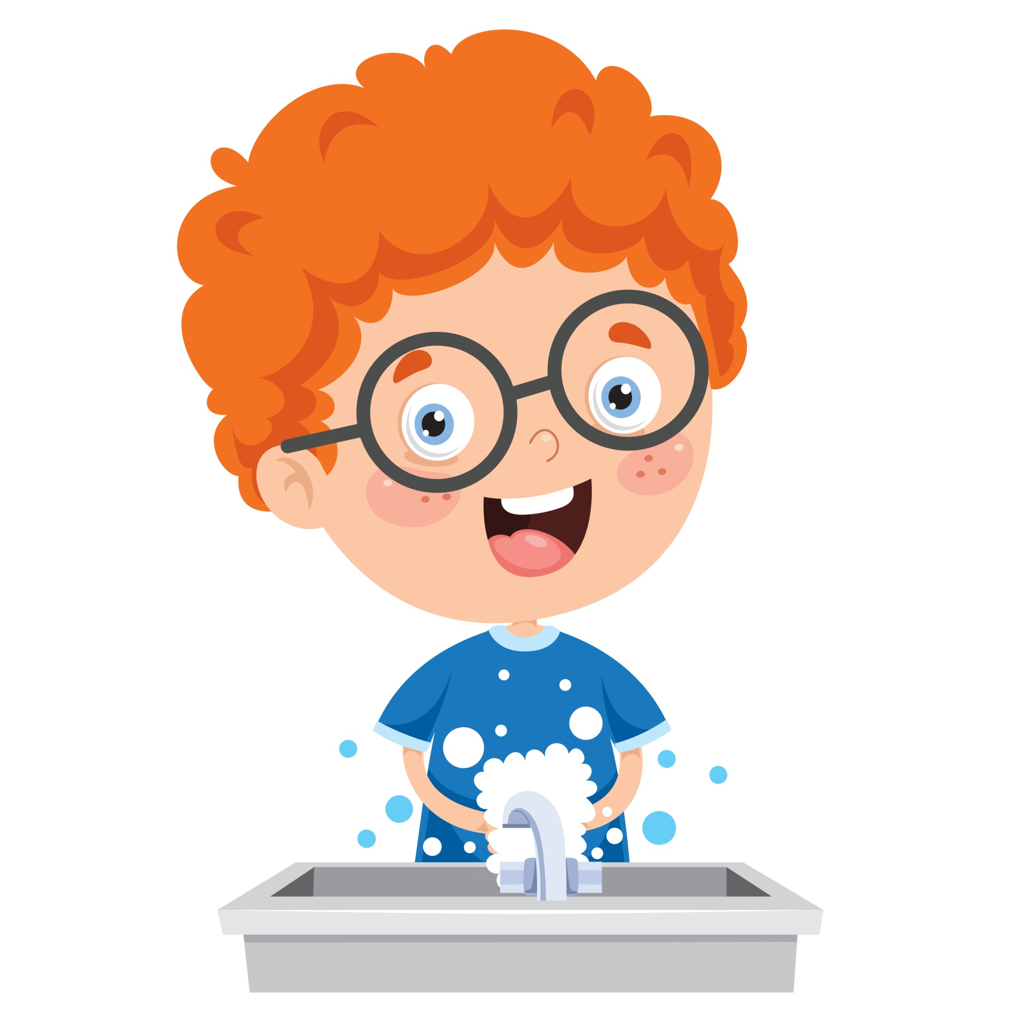

1. Brushing teeth

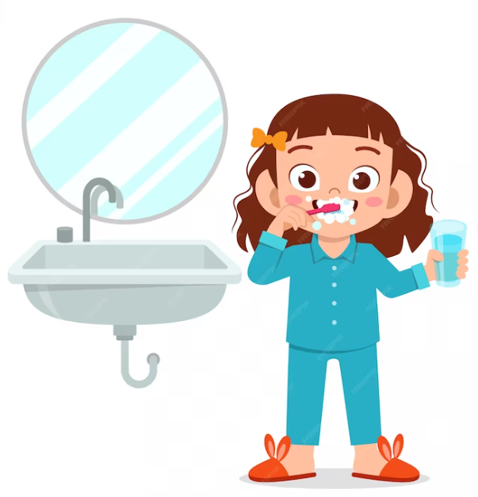

1. Playing sports

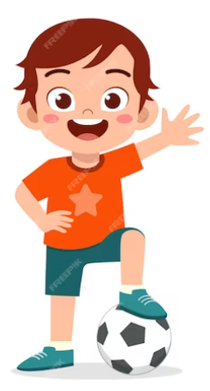

1. Washing hands

**Part 5: My Healthy Routine**

**E. Draw a picture of yourself doing something healthy.**

**Part 6: Vocabulary**

**F. Match the word to its meaning:**

1. **Healthy** Tiny things that make you sick
2. **Bath** Feeling good and strong
3. **Germs** Clean your body with water

**My Friends**

**Part 1: Describing Friends**

**A. Fill in the blanks to describe your friend:**

1. My friend's name is ______________________.
2. My friend has ______________________ hair. *(black, brown, blond)*
3. My friend has ______________________ eyes. *(blue, green, brown)*

**Part 2: Friend Activities**

**B. Circle what you like to do with your friend:**

1. **Play games**  
   🏃 🎲 🎮
2. **Share toys**  
   🧸 🚗 🏀
3. **Eat together**  
   🍎 🍔 🍕

**Part 3: Similarities and Differences**

**C. Draw a picture of you and your friend.**

* How are you and your friend the same?
* How are you and your friend different?

**Part 4: Sharing**

**D. Circle the good ways to share with your friend:**

1. Sharing crayons  
   🖍️ Yes / No
2. Sharing food  
   🍕 Yes / No
3. Playing together  
   🏀 Yes / No

**Part 5: Being a Good Friend**

**E. Match the sentence to the right picture:**

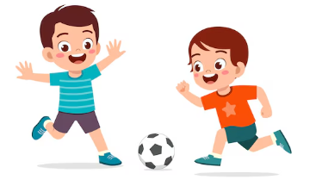

1. I help my friend.

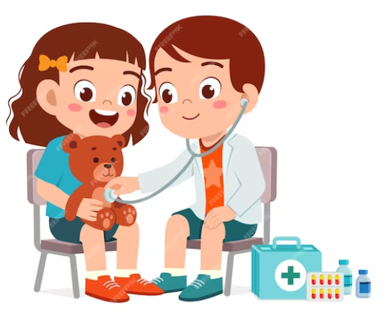

1. I share my toys.

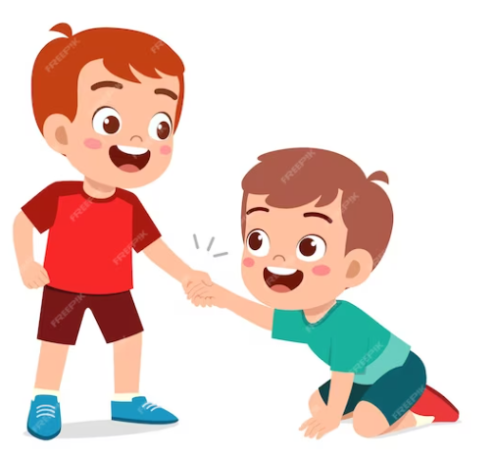

1. I play with my friend.

**Part 6: Vocabulary**

**F. Match the word to its meaning:**

1. Friend Being nice to others
2. Share To let someone use something with you
3. Kind Someone you like to play with

**My Family**

**Part 1: My Family Members**

**A. Fill in the blanks:**

1. My father's name is ______________________.
2. My mother's name is ______________________.
3. I have ______________________brothers and ______________________sisters.
4. My grandmother's name is ______________________.
5. My grandfather's name is ______________________.

**Part 2: Family Activities**

**B. Circle the things you do with your family:**

1. Eat dinner together  
   🍽️ Yes / No
2. Play games together  
   🏓 Yes / No
3. Help each other  
   🤝 Yes / No
4. Go to the park together  
   🌳 Yes / No

**Part 3: Family Roles**

**C. Match the family member to what they do:**

1. Mother Works at a job
2. Father Helps me
3. Brother/Sister Tells me stories
4. Grandparents Plays with me

**Part 4: Family Tree**

**D. Draw your family in the boxes below.**  
*(Draw your mother, father, brothers, sisters, grandparents, and yourself.)*

**Part 5: Family Values**

**E. Circle the good behaviors towards your family:**

1. Listening to your parents  
   👂 Yes / No
2. Arguing with your siblings  
   💢 Yes / No
3. Helping your grandparents  
   👵 Yes / No
4. Showing respect to everyone  
   🙏 Yes / No

**Part 6: Vocabulary**

**F. Match the word to its meaning:**

1. Parent Being kind and polite to others
2. Sibling Your parent’s parent
3. Grandparent Your father or mother
4. Respect Your brother or sister

**My Relatives**

**Part 1: Who Are My Relatives?**

**A. Fill in the blanks:**

1. My uncle’s name is ______________________.
2. My aunt’s name is ______________________.
3. My cousins’ names are ______________________ and ______________________.
4. My grandparents’ names are ______________________ and ______________________.

**Part 2: Family Events**

**B. Circle the occasions when you see your relatives:**

1. Birthday parties 🎂  
   Yes / No
2. Eid Al-Fitr 🕌  
   Yes / No
3. At school 🎒  
   Yes / No
4. Family picnics 🧺   
   Yes / No

**Part 3: Showing Respect**

**C. Match the ways you show love and respect to your relatives:**

1. Help your grandparents Share your toys
2. Listen to your parents Help them carry things
3. Play with your cousins Do what they ask you to do

**Part 4: My Favorite Relative**

**D. Draw a picture of your favorite relative and write their name.**

**Part 5: Celebrating With Relatives**

**E. Circle what you do with your relatives on special occasions:**

1. Eat together  
   🍽️ Yes / No
2. Play games  
   🎲 Yes / No
3. Exchange gifts  
   🎁 Yes / No
4. Tell stories  
   📖 Yes / No

**Part 6: Vocabulary**

**F. Match the word to its meaning:**

1. Uncle The children of your aunts or uncles
2. Aunt Your parents’ parents
3. Cousin Your father or mother’s brother
4. Grandparents Your father or mother’s sister

**All Around Me**

**Part 1: About My House**

**A. Fill in the blanks:**

1. I live in a ______________________.
2. My house has ______________________ rooms.
3. My house is on ______________________ street.
4. My room is ______________________ color.

**Part 2: Things in My House**

**B. Match the items with the room they belong to:**

1. Bed Bathroom
2. Sofa Kitchen
3. Shower Bedroom
4. Stove Living room

**Part 3: House Activities**

**C. Circle the things you do in your house:**

1. **Sleeping**  
   🛏️ Yes / No
2. **Eating meals**  
   🍽️ Yes / No
3. **Playing games**  
   🎮 Yes / No
4. **Doing homework**  
   📚 Yes / No

**Part 4: Keeping the House Clean**

**D. Draw yourself doing something to keep the house clean.**

**Part 5: Vocabulary**

**E. Match the word to its meaning:**

1. House A part of a house like the kitchen or bedroom
2. Room To make things neat and tidy
3. Clean A place where you live

**Part 6: My Dream House**

**F. Draw your dream house and color it.**

**My School**

**Part 1: About My School**

**A. Fill in the blanks:**

1. My school’s name is ______________________.
2. My teacher’s name is ______________________.
3. My favorite subject is ______________________.
4. My favorite place in the school is ______________________.

**Part 2: School Rooms**

**B. Match the rooms to what happens there:**

1. Classroom Where we eat
2. Playground Where we study
3. Cafeteria Where we read books
4. Library Where we play

**Part 3: School Subjects**

**C. Circle the subjects you study at school:**

1. **Math**  
   ✏️ Yes / No
2. **English**  
   📚 Yes / No
3. **Science**  
   🧪 Yes / No
4. **Art**  
   🎨 Yes / No

**Part 4: My Classroom**

**D. Draw a picture of your classroom.**  
*(Draw your desk, teacher, and friends.)*

**Part 5: School Rules**

**E. Circle the good behaviors at school:**

1. Listening to the teacher  
   👂 Yes / No
2. Running inside the classroom  
   🏃 Yes / No
3. Sharing with your friends  
   🧸 Yes / No
4. Being kind to others  
   💕 Yes / No

**Part 6: Vocabulary**

**F. Match the word to its meaning:**

1. School A person who helps you learn
2. Classroom A place where children learn
3. Teacher A room where students learn

**My Neighbourhood**

**Part 1: About My Neighbourhood**

**A. Fill in the blanks:**

1. I live in ______________________.
2. There are ______________________ houses in my neighborhood.
3. I go to the ______________________ with my family.
4. I see ______________________ and ______________________ in my neighborhood.

**Part 2: Places in My Neighbourhood**

**B. Match the place to what happens there:**

1. Park Where we learn
2. Shop Where we pray
3. Mosque Where we buy things
4. School Where we play and run

**Part 3: My Favorite Place**

**C. Draw a picture of your favorite place in your neighborhood.**  
*(Draw a place like a park, shop, or mosque.)*

**Part 4: Helping in the Neighbourhood**

**D. Circle the good things you can do in your neighborhood:**

1. Throw trash in the bin  
   🗑️ Yes / No
2. Help your neighbors  
   🤝 Yes / No
3. Litter on the ground  
   🗑️ Yes / No
4. Keep the streets clean  
   🧹 Yes / No

**Part 5: Directions**

**E. Complete the sentences about directions:**

1. The park is (near / far) from my house.
2. I walk to the shop with my family. (True / False)
3. The school is to the (left / right) of my house.
4. The mosque is behind the ______________________.

**Part 6: Vocabulary**

**F. Match the word to its meaning:**

1. Neighbourhood A place where you buy things
2. Neighbour The area around your house
3. Shop A person who lives near you

**My Country**

**Part 1: About My Country**

**A. Fill in the blanks:**

1. The name of my country is ______________________.
2. The capital city of my country is ______________________.
3. The flag of my country has the colors ______________________, ______________________, and ______________________.
4. The ruler of my country is ______________________.

**Part 2: Cities in My Country**

**B. Match the cities to what they are known for:**

1. Capital city Where people visit for holidays
2. Tourist city Where there is lots of sand
3. Coastal city Where the government is
4. Desert city Where the sea is nearby

**Part 3: The Flag of My Country**

**C. Draw and color the flag of your country.**

**Part 4: Special Landmarks**

**D. Draw a famous building or landmark in your country.**  
*(Examples: A famous tower, a mosque, or a monument.)*

**Part 5: National Pride**

**E. Circle the things you can do to show pride in your country:**

1. Respect the flag  
   🇦🇪 Yes / No
2. Follow the rules  
   📜 Yes / No
3. Litter the streets  
   🗑️ Yes / No
4. Help your community  
   🤝 Yes / No

**Part 6: Vocabulary**

**F. Match the word to its meaning:**

1. Country A famous building or place in a country
2. Capital city The main city where the government is
3. Flag A symbol of the country with colors and shapes
4. Landmark A place where people live and have a  
    government

**The Sun**

**Part 1: The Sun and Time**

**A. Fill in the blanks:**

1. The sun rises in the ______________________.
2. The sun sets in the ______________________.
3. The time when the sun comes up in the morning is called ______________________.
4. The time when the sun goes down in the evening is called ______________________.

**Part 2: Day and Night**

**B. Circle the activities that happen during the day and cross out the ones that happen at night:**

1. 🌞 **Playing outside**  
   Day / Night
2. 🌙 **Sleeping**  
   Day / Night
3. 🌞 **Going to school**  
   Day / Night
4. 🌙 **Watching stars**Day / Night

**Part 3: The Sun’s Movement**

**C. Circle True or False:**

1. The sun rises in the east.  
    True / False
2. The sun sets in the north.  
    True / False
3. The sun helps to give us light and warmth.  
    True / False
4. The sun moves around the Earth.  
    True / False

**Part 4: The Sun in the Sky**

**D. Draw a picture of the sun rising in the east and setting in the west.**

**Part 5: Vocabulary**

**E. Match the word to its meaning:**

1. Sunrise The direction where the sun rises
2. Sunset The direction where the sun sets
3. East When the sun comes up in the morning
4. West When the sun goes down in the evening

**The Compass Rose**

**Part 1: Understanding the Compass Rose**

**A. Fill in the directions on the compass:**

1. **N** stands for ______________________.
2. **S** stands for ______________________.
3. **E** stands for ______________________.
4. **W** stands for ______________________.

**Part 2: Directions on a Map**

**B. Look at the map below and answer the questions:**

1. The park is to the **north** of the school.  
    True / False
2. The library is to the **east** of the shop.  
    True / False
3. The playground is to the **west** of the house.  
    True / False
4. The mosque is to the **south** of the park.  
    True / False

**Part 3: Drawing Directions**

**C. Draw arrows to show the directions:**

1. Draw an arrow pointing **north**.
2. Draw an arrow pointing **south**.
3. Draw an arrow pointing **east**.
4. Draw an arrow pointing **west**.

**Part 4: Using a Compass Rose**

**D. Answer the questions using the compass rose:**

1. If I am facing north and I turn to my right, which direction am I facing?  
   _____________________________________________________________________________
2. If I am facing east and I turn to my left, which direction am I facing?  
   _____________________________________________________________________________
3. If I am facing south and I turn all the way around, which direction am I facing?  
   _____________________________________________________________________________

**Part 5: Vocabulary**

**E. Match the word to its meaning:**

1. Compass Rose The direction where the sun rises
2. North The direction opposite to north
3. South The direction where the sun sets
4. East The direction at the top of the compass
5. West A tool that shows directions on a map

**Map Skills**

**Part 1: Understanding Map Symbols**

**A. Match the symbol to its meaning:**

1. **🏫 Park**
2. **🏠 Shop**
3. **🌳 School**
4. **📚 Library**
5. **🛒 House**

**Part 2: Reading the Map Key**

**B. Look at the map key and answer the questions:**

1. What symbol is used for the **school**?
2. What symbol is used for the **park**?
3. What symbol is used for the **house**?
4. What symbol is used for the **library**?

**Part 3: Drawing with Symbols**

**C. Draw the symbols for these places:**

1. Draw the symbol for a **school**.
2. Draw the symbol for a **house**.
3. Draw the symbol for a **park**.
4. Draw the symbol for a **shop**.

**Part 4: Using a Map Key**

**D. Answer the following questions using the map key:**

1. If you are at the house and want to go to the park, which direction should you go?  
   *__________________________________________________________________*
2. What is located east of the shop on the map?  
   *__________________________________________________________________*
3. What is south of the library on the map?  
   *__________________________________________________________________*

**Part 5: Vocabulary**

**E. Match the word to its meaning:**

1. Map key A small picture that represents something on  
    the map
2. Symbol A picture that shows where places are
3. Map A list of symbols on a map and what they mean

**The Map of My City**

**Part 1: Places in My City**

**A. Match the places to what happens there:**

1. School Where we buy things
2. Library Where we play
3. Park Where we read books
4. Shop Where we learn

**Part 2: Reading the Map**

**B. Use the map of the city to answer the questions:**

1. What is **north** of the park?

_____________________________________________________________________

1. What is **south** of the school?

_____________________________________________________________________

1. What is **west** of the shop?

_____________________________________________________________________

1. What is **east** of the library?

_____________________________________________________________________

**Part 3: Drawing Your City**

**C. Draw a simple map of your city and label the following:**

1. Your **house**
2. Your **school**
3. A **shop**
4. A **park**

**Part 4: Using Directions**

**D. Fill in the blanks using north, south, east, or west:**

1. My house is ______________________ of the park.
2. The school is ______________________ of the shop.
3. The library is ______________________ of the park.
4. The shop is ______________________ of the house.

**Part 5: Vocabulary**

**E. Match the word to its meaning:**

1. City A place where people can play and relax
2. Map North, south, east, and west
3. Park A drawing that shows where places are
4. Directions A large place where people live and   
    work

**The Arab World**

**Part 1: Countries in the Arab World**

**A. Match the country to its capital:**

1. Jordan Abu Dhabi
2. UAE Riyadh
3. Egypt Amman
4. Saudi Arabia Cairo

**Part 2: Map of the Arab World**

**B. Use the map of the Arab world to answer the questions:**

1. What country is **north** of Saudi Arabia?

_____________________________________________________________________

1. What country is **west** of the UAE?

_____________________________________________________________________

1. What sea is **south** of Egypt?

_____________________________________________________________________

1. What is the **capital** of Jordan?

_____________________________________________________________________

**Part 3: Famous Places in the Arab World**

**C. Match the famous place to the country:**

1. Burj Khalifa Egypt
2. Pyramids of Giza Saudi Arabia
3. Petra Jordan
4. Kaaba UAE

**Part 4: Draw and Color**

**D. Draw and color a flag from one country in the Arab world.**  
*(Example: Draw and color the flag of the UAE or Jordan.)*

**Part 5: Vocabulary**

**E. Match the word to its meaning:**

1. Capital A symbol of a country with colors and  
    shapes
2. Arab World A place where people live, with its own  
    land and government
3. Country The main city of a country
4. Flag Countries where Arabic is spoken

**Living in the Past**

**Part 1: Life in the Past**

**A. Circle what people used in the past:**

1. Carriages or Cars
2. Candles or Electric lights
3. Horses or Bicycles
4. Wooden houses or Skyscrapers

**Part 2: Old and New Objects**

**B. Match the old objects with their modern versions:**

1. **Candles**  
   a. Light bulbs
2. **Horse and carriage**  
   b. Cars
3. **Letters**  
   c. Emails
4. **Old telephones**  
   d. Smartphones

**Part 3: How People Lived**

**C. Answer the questions:**

1. How did people **travel** in the past?  
   __________________________________________________________________
2. What did people use for **light** in the past?

__________________________________________________________________

1. How did people send **messages** in the past?

__________________________________________________________________

**Part 4: Draw and Compare**

**D. Draw a picture of something from the past and its modern version.**  
*(Example: Draw a horse and carriage next to a car.)*

**Part 5: Vocabulary**

**E. Match the word to its meaning:**

1. Past Something that is new or happening now
2. Carriage A stick of wax used for light
3. Candle A vehicle pulled by horses
4. Modern Time before now

**Living Nowadays**

**Part 1: Life Today**

**A. Circle what people use today:**

1. Smartphones or Old telephones
2. Electric cars or Horse and carriage
3. LED lights or Candles
4. Airplanes or Ships with sails

**Part 2: Modern Objects**

**B. Match the objects with what they are used for today:**

1. Smartphone To do work or play games
2. Car To watch shows and movies
3. Computer To call and message people
4. Television To travel quickly

**Part 3: Our Daily Life**

**C. Answer the questions:**

1. How do people travel today?

_____________________________________________________________________

1. What do people use to talk to others today?

_____________________________________________________________________

1. What do people watch for fun today?

_____________________________________________________________________

**Part 4: Draw and Label**

**D. Draw a picture of something you use every day and write its name.  
*(Example: Draw a smartphone or computer.)***

**Part 5: Vocabulary**

**E. Match the word to its meaning:**

1. Nowadays A device to call, text, and use the  
    internet
2. Smartphone Something that is new or happening  
    now
3. Electric car How we live now
4. Modern A car that runs on electricity

**Professions**

**Part 1: Old Professions vs. Modern Professions**

**A. Match the old professions to their modern equivalents:**

1. Blacksmith Electrician
2. Farmer Mail carrier
3. Candle maker Factory worker
4. Messenger Engineer

**Part 2: Types of Professions**

**B. Circle the jobs that people do today:**

1. Teacher or Blacksmith
2. Doctor or Candle maker
3. Pilot or Horse rider
4. Computer programmer or Farmer

**Part 3: Tools for the Job**

**C. Match the profession to the tool they use:**

1. Teacher Airplane
2. Doctor Hammer
3. Pilot Stethoscope
4. Construction worker Chalkboard

**Part 4: Draw and Label**

**D. Draw a picture of a profession you like and label it.  
*(Example: Draw a doctor, teacher, or firefighter.)***

**Part 5: Vocabulary**

**E. Match the word to its meaning:**

1. Profession A person who helps sick people
2. Teacher Someone who designs and builds things
3. Doctor A job or work someone does
4. Engineer Someone who helps students learn

**Food**

**Part 1: Food in the Past vs. Food Today**

**A. Circle the foods people ate in the past:**

1. **Homemade bread** or **Packaged bread**
2. **Fresh vegetables** or **Frozen vegetables**
3. **Fruit picked from trees** or **Canned fruit**
4. **Water from wells** or **Bottled water**

**Part 2: Cooking Tools**

**B. Match the cooking tools from the past to their modern equivalents:**

1. Wood-burning stove Non-stick pans
2. Mortar and pestle Electric stove
3. Clay pots Microwave
4. Open fire Blender

**Part 3: How We Eat**

**C. Answer the questions:**

1. How did people cook food in the past?

_____________________________________________________________________

1. How do people cook food today?

_____________________________________________________________________

1. What did people drink in the past?

_____________________________________________________________________

**Part 4: Draw and Compare**

**D. Draw a picture of a meal from the past and a meal from today.**  
*(Example: Draw a homemade meal vs. a fast-food meal.)*

**Part 5: Vocabulary**

**E. Match the word to its meaning:**

1. Fresh Something that is new or happening now
2. Modern Food that is eaten at one time
3. Cook Food that is newly picked or made
4. Meal To prepare food for eating

**Clothes**

**Part 1: Types of Homes**

**A. Circle the homes that people lived in long ago:**

1. Cottages or Apartments
2. Mud houses or Skyscrapers
3. Tents or Modern houses
4. Castles or Condominiums

**Part 2: Old vs. Modern Homes**

**B. Match the old types of homes to their modern equivalents:**

1. Mud house Skyscraper
2. Tent Modern house
3. Cottage Brick house
4. Castle Apartment

**Part 3: Living in the Past and Present**

**C. Answer the questions:**

1. What were houses made of in the past?

_____________________________________________________________________

1. What are houses made of today?

_____________________________________________________________________

1. How did people stay warm in the past?

_____________________________________________________________________

1. How do people stay warm in modern homes?

_____________________________________________________________________

**Part 4: Draw and Compare**

**D. Draw a picture of a house from the past and a house from today.**  
*(Example: Draw a mud house or tent and a modern apartment building.)*

**Part 5: Vocabulary**

**E. Match the word to its meaning:**

1. Cottage A temporary shelter made of fabric
2. Modern A very tall building
3. Skyscraper A small, simple house
4. Tent Something new or recent

**Jobs**

**Part 1: Understanding Money**

**A. Circle the things we use money to buy:**

1. Toys or Homework
2. Food or Dreams
3. Clothes or Happiness
4. Books or Clouds

**Part 2: What is Money?**

**B. Match the picture to the type of money:**

1. Coins Metal money
2. Bills Paper money

**Part 3: Why Do We Use Money?**

**C. Fill in the blanks:**

1. People use money to buy _____________________.
2. We earn money by working in different _____________________.
3. You can save money to buy something special like a _____________________.

**Part 4: Draw and Label**

**D. Draw a picture of something you can buy with money and label it.**  
*(Example: Draw a toy, food, or clothes.)*

**Part 5: Vocabulary**

**E. Match the word to its meaning:**

1. Money To give money to get something
2. Save Coins and bills used to buy things
3. Earn To keep money for later
4. Buy To get money for doing work

**Health Care Jobs**

**Part 1: Health Care Workers**

**A. Match the health care job to what they do:**

1. Doctor Gives medicine
2. Nurse Takes care of teeth
3. Dentist Helps sick people
4. Pharmacist Takes care of patients

**Part 2: What Tools Do They Use?**

**B. Match the health care worker to the tool they use:**

1. Doctor Toothbrush
2. Dentist Medicine bottles
3. Nurse Stethoscope
4. Pharmacist Thermometer

**Part 3: How They Help Us**

**C. Answer the questions:**

1. Who helps you when you are sick?

_____________________________________________________________________

1. Who takes care of your teeth?

_____________________________________________________________________

1. Who gives you medicine when you need it?

_____________________________________________________________________

**Part 4: Draw and Label**

**D. Draw a picture of a health care worker and label it.**  
*(Example: Draw a doctor, nurse, or dentist.)*

**Part 5: Vocabulary**

**E. Match the word to its meaning:**

1. Doctor A person who gives medicine
2. Nurse A person who takes care of teeth
3. Dentist A person who helps sick people
4. Pharmacist A person who takes care of patients

**Construction Jobs**

**Part 1: Construction Workers**

**A. Match the construction job to what they do:**

1. Builder Fixes pipes and water systems
2. Architect Works with wires and electricity
3. Electrician Builds houses and buildings
4. Plumber Designs buildings

**Part 2: Tools They Use**

**B. Match the construction worker to the tool they use:**

1. Builder Blueprints
2. Architect Wrench
3. Electrician Hammer
4. Plumber Wires

**Part 3: How They Help Us**

**C. Answer the questions:**

1. Who builds houses and buildings?

_____________________________________________________________________

1. Who designs the buildings?

_____________________________________________________________________

1. Who works with electricity in the house?

_____________________________________________________________________

1. Who fixes water pipes and systems?

_____________________________________________________________________

**Part 4: Draw and Label**

**D. Draw a picture of a construction worker and label it.**  
*(Example: Draw a builder, electrician, or plumber.)*

**Part 5: Vocabulary**

**E. Match the word to its meaning:**

1. Builder A person who designs buildings
2. Architect A person who fixes pipes and water systems
3. Electrician A person who builds houses and buildings
4. Plumber A person who works with wires and electricity

**Astronauts**

**Part 1: What Do Astronauts Do?**

**A. Match the astronaut's job to what they do:**

1. Train in space suits To learn about space
2. Fly into space To work and stay in space
3. Conduct experiments To prepare for space travel
4. Live in space stations To explore planets and stars

**Part 2: Astronaut's Tools**

**B. Match the astronaut's tool to its use:**

1. Space suit Protects their head in space
2. Rocket Helps them stay safe in space
3. Helmet Food astronauts eat in space
4. Space food Takes them into space

**Part 3: Life as an Astronaut**

**C. Answer the questions:**

1. What do astronauts wear to stay safe in space?

_____________________________________________________________________

1. How do astronauts travel to space?

_____________________________________________________________________

1. Where do astronauts live while in space?

_____________________________________________________________________

1. What do astronauts do in space?

_____________________________________________________________________

**Part 4: Draw and Label**

**D. Draw a picture of an astronaut in space and label it.**  
*(Example: Draw an astronaut in a space suit with a helmet, and label the rocket.)*

**Part 5: Vocabulary**

**E. Match the word to its meaning:**

1. Astronaut Clothing that keeps astronauts safe in space
2. Rocket A person who travels into space
3. Space suit A vehicle that flies into space
4. Experiment A test to learn new things

**Sources of Water**

**Part 1: Where Does Water Come From?**

**A. Circle the sources of water:**

1. Rain or Sun
2. Rivers or Mountains
3. Lakes or Roads
4. Oceans or Houses

**Part 2: Types of Water Sources**

**B. Match the water source to its type:**

1. River Water from the sky
2. Ocean Freshwater
3. Lake Saltwater
4. Rain Freshwater

**Part 3: Water Around Us**

**C. Answer the questions:**

1. Where does the water in rivers come from?

________________________________________________________________

1. What type of water is found in oceans?

________________________________________________________________

1. Where does rain come from?

________________________________________________________________

1. What type of water do we drink?

________________________________________________________________

**Part 4: Draw and Label**

**D. Draw a picture of a source of water and label it.**  
*(Example: Draw a river, lake, or rain.)*

**Part 5: Vocabulary**

**E. Match the word to its meaning:**

1. Rain A large stream of water that flows
2. River Water that is clean and safe to drink
3. Ocean Water that falls from the sky
4. Freshwater A large body of saltwater

**Uses of Water 1**

**Part 1: How We Use Water**

**A. Circle the activities where we use water:**

1. Drinking or Running
2. Washing dishes or Writing
3. Cooking or Playing video games
4. Watering plants or Painting

**Part 2: Daily Uses of Water**

**B. Match the water use to its activity:**

1. Drinking Keeps us clean
2. Washing hands Helps us make meals
3. Cooking food Helps plants grow
4. Watering plants Keeps us healthy

**Part 3: Water in Our Daily Lives**

**C. Answer the questions:**

1. What do you use water for every day?

____________________________________________________________________

1. Why is drinking water important?

____________________________________________________________________

1. How does water help plants grow?

____________________________________________________________________

**Part 4: Draw and Label**

**D. Draw a picture of something you do with water and label it.**  
*(Example: Draw yourself washing your hands or watering plants.)*

**Part 5: Vocabulary**

**E. Match the word to its meaning:**

1. Drink To get bigger or develop
2. Cook To take in water
3. Wash To prepare food
4. Grow To clean something with water

**Uses of Water 2**

**Part 1: More Ways We Use Water**

**A. Circle the activities where we use water:**

1. Swimming or Running
2. Cleaning the house or Drawing
3. Putting out fires or Jumping rope
4. Bathing or Playing soccer

**Part 2: Special Uses of Water**

**B. Match the use of water to the action:**

1. Swimming To make things clean
2. Cleaning To stop a fire from burning
3. Putting out fires To wash our bodies
4. Bathing For exercise and fun

**Part 3: Why Water is Important**

**C. Answer the questions:**

1. How do firefighters use water?

____________________________________________________________________

1. Why do we need water for cleaning?

____________________________________________________________________

1. How does water help us when we swim?

____________________________________________________________________

**Part 4: Draw and Label**

**D. Draw a picture of another way we use water and label it.**  
*(Example: Draw yourself swimming or helping to clean the house.)*

**Part 5: Vocabulary**

**E. Match the word to its meaning:**

1. Bath To remove dirt or make something tidy
2. Swim A time when you clean your body with water
3. Firefighter To move through water
4. Clean A person who puts out fires

**Saving Water**

**Part 1: How to Save Water**

**A. Circle the actions that help save water:**

1. Turning off the tap or Leaving the tap running
2. Using a bucket to wash the car or Using a hose to wash the car
3. Taking short showers or Taking long baths
4. Fixing a dripping tap or Ignoring a dripping tap

**Part 2: How Can We Save Water?**

**B. Match the action to how it helps save water:**

1. Turning off the tap while brushing teeth Prevents water loss
2. Using a bucket to wash the car Stops wasting water
3. Fixing a dripping tap . Uses less water
4. Taking short showers Uses less water

**Part 3: Why is Saving Water Important?**

**C. Answer the questions:**

1. Why should we turn off the tap when it’s not in use?

____________________________________________________________________

1. How does fixing a dripping tap help save water?

____________________________________________________________________

1. Why should we take short showers instead of long baths?

____________________________________________________________________

**Part 4: Draw and Label**

**D. Draw a picture of something you can do to save water and label it.**  
*(Example: Draw yourself turning off the tap.)*

**Part 5: Vocabulary**

**E. Match the word to its meaning:**

1. Tap A way to clean yourself using water
2. Shower To repair something that is broken
3. Bucket A device that controls the flow of water
4. Fix A container used to hold water