**UNIT 9: Magnetism**

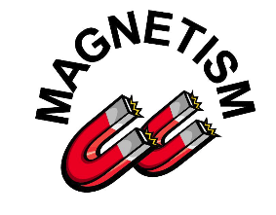

1. **Fill in blanks**.
2. A Magnet is ____________________________.
3. Materials that can attract metals such as iron, steel, cobalt are called____________________________.
4. The area around a magnet where the force of magnet can be felt is called____________________________.
5. An object that is made of hard steel will remain a magnet for a long time is ____________________________magnet.
6. An object that is made of soft iron loses its magnetism after some time is called ____________________________magnet.
7. Electromagnet is a temporary magnet it behaves like a magnet only when ____________________________is flowing through it.
8. Keeper is_________________________________________.
9. _____________is a small instrument that helps us to find directions.
10. **Write repel or attract**.

**S**

**N**

**N**

**N**

_________________ ________________