**Unit 7: Work and Machines**

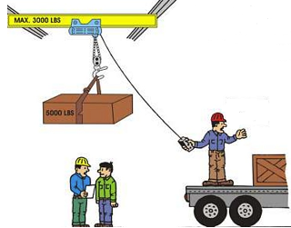

1. **Fill in blanks**.

a) The food of machine is called…………

b) A steam-engine needs………

c) A car needs…………………………

d) The fuel of our body is…………….

e) Fuel gives…………….to the machine to do work.

1. **Write Yes or No**.
2. A push or pull is called force……….
3. We can move things only by pushing them…….
4. Food gives energy to work and play………….
5. Crane is a small machine to open a bottle……..
6. Scissor is a big machine which picks up heavy loads……