**Student's name: _____________ Date: / /   
  
Unit 8: The moon**  
  
  
**1. True or false**  
  
 1. We can see the moon in the sky at night. ( )

2. The moon has air and water. ( )

3. The moon is close from the earth. ( )  
  
  
**2. Choose the correct answer.**  
  
1. Sun rises in the _________. (east/west)

2. We can see the moon at _________. (day/night)

3. No one lives on. (Moon/earth)

**3. Color this paint.**   
  
 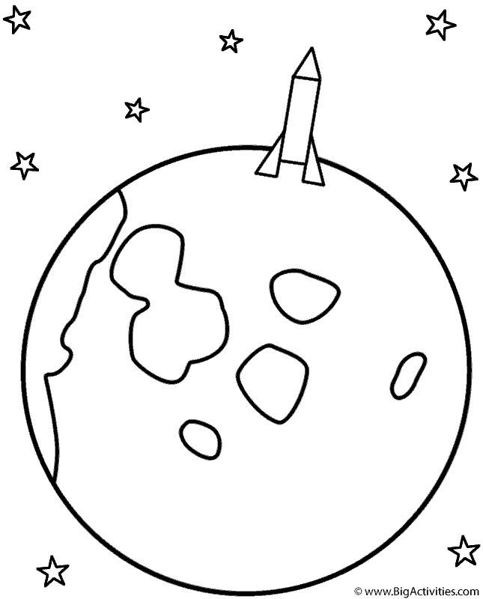 1969 APOLLO