**UNIT 1: Reproduction in Animals**

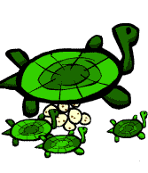

1. **Label the life cycle of a butterfly?**

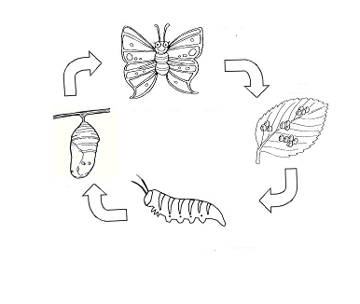

**2. Label the life cycle of a fish?**

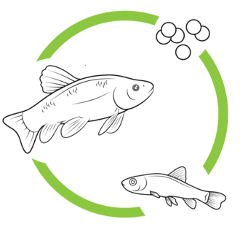

1. **Label the life cycle of a frog?**

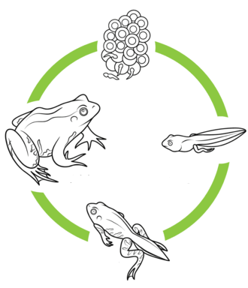

1. **Label the parts of the flower :**

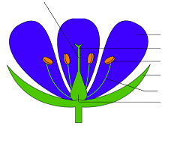

1. **Draw the stages in germination of a bean seed.**

|  |
| --- |
|  |

1. **Read the statements below. Decide if they are true or false.**

|  |  |  |
| --- | --- | --- |
| Statements | True | False |
| 1. Living things make new living things of their own kind by reproduction**.** |  |  |
| 1. In most fish, the female lays egg in bunches in the land. |  |  |
| 1. Birds sit on the eggs and keep them warm. |  |  |
| 1. As soon as baby is born in mammals it begins to feed on grass. |  |  |
| 1. Carrying male cell which joins with female cell of the ovule, this process is called fertilization. |  |  |