**UNIT 2: Food and Diet**

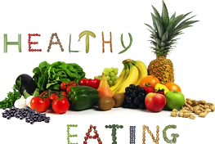

1. **Read the statements below. Decide if they are true or false.**

|  |  |  |
| --- | --- | --- |
| Statements | True | False |
| 1. Plants donot eat food from outside. |  |  |
| 1. Plants make simple sugars such as glucose. |  |  |
| 1. Seeds may store starch and oil. |  |  |
| 1. Proteins, fats and carbohydrates are called welfare food substances. |  |  |
| 1. If we eat too little food, we become fat. |  |  |

1. **Fill in blanks**
2. Carbohydrates give us_________________________________.
3. _________________are used for growth of the body.
4. _________________and _________________have fats in them.
5. Some of the important vitamins are _________________and _________________
6. Vitamin A is found in_________________
7. Calcium is good for _________________
8. Two-thirds of our body is made of _________________