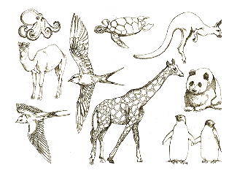**Unit 2: Types of living Things; Animals**

1. **Fill in blanks to complete the sentences**.
2. All animals can be put into one group_________group.
3. All plants can be put into another group _________group.
4. Animals can be further put into other groups called _________
5. A skeleton is made up of _________
6. Starfish have rough skin with sharp needle-like called_________
7. Sea urchin can swim in the water with _________
8. Spider has _________legs.
9. A butterfly has _________legs.
10. The body of an insect has three parts_________, _________, and abdomen.
11. Read the statements below. Decide whether the statements are true or false.

|  |  |  |
| --- | --- | --- |
| Statement | True | False |
| Most fish have scales on their skin. |  |  |
| An amphibian spends all of its life in water. |  |  |
| Reptiles breathe air through their scaly skins. |  |  |
| Birds bodies are covered with fur. |  |  |
| Mammals’ skin is covered with hair or fur. |  |  |
| Mammal breathes through their lungs |  |  |

1. **Choose the best answer**.
2. Sea urchins has ( bone/spines)
3. Mammals covered with ( a fur/ spines)
4. Tapeworms have (hard/soft) bodies.
5. Crocodiles breathe through their (lungs/gills)
6. Amphibians live (in water/ on land and water)
7. Animals with backbone can be divided into five classes. Mention three of them.
8. ________________________________
9. ________________________________
10. ________________________________
11. Complete the table below.

frogs - ostrich – starfish – crocodiles - snails – spiders – snakes

|  |  |
| --- | --- |
| Animals with spines |  |
| Worms |  |
| Animals with jointed legs |  |
| Animals with shells |  |
| Reptiles |  |
| Amphibians |  |
| Birds |  |

1. Draw a fish. Write the parts of its body.

|  |
| --- |
|  |