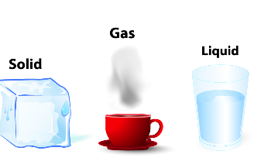 **Unit 4: Matter**

**1) From the list choose (solids, liquids and gases).**

|  |  |  |  |  |
| --- | --- | --- | --- | --- |
| Steam  Brick | Water  Stone | Air  Smoke | table  Soil | milk  Juice |

|  |  |  |
| --- | --- | --- |
| Gases | Liquids | Solids |
| _______________  _______________  _______________  _______________  _______________ | _______________  _______________  _______________  _______________  _______________ | _______________  _______________  _______________  _______________  _______________ |

**2) Write Yes or No.**

1. Matter consists of many colors _______________
2. Matter changes_______________
3. Solid can flow_______________
4. Gas has a fixed shape _______________
5. Matter can only be liquid _______________

**3) Fill in blanks**

**1.** Solid is _______________.

2. Liquid can _______________.

3. Gas can move from _______________to _______________.

4. All living things live on _______________.

**4**. **Color the living things.**

