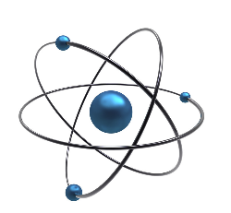**UNIT 4: Atoms and Molecules**

1. **Fill in blanks with the correct answer.**
2. Anything which takes up space and has weight is called___________________.
3. Matter is made up of very tiny particles called___________________.
4. Atoms join up to form ___________________.
5. An atom is a tiny particle which has a ___________________in the center.
6. The nucleus is made up of particles called_____________ and_____________.
7. Around the nucleus there are much smaller, lighter particles called__________.
8. The number of protons and electrons is___________________.
9. Carbon, silver, gold and oxygen are___________________.
10. Substances which have atoms of more than one kind are called_____________.
11. Elements have been sorted in two groups: _____________and_____________.
12. Iron, gold, silver, and copper are example of ___________________________.
13. Heat and electricity can easily pass through____________________________.
14. Sulfur, oxygen, nitrogen and carbon are_______________________________.
15. The temperature at which a solid changes into a liquid is called it’s ________.
16. The temperature at which a liquid boils is called it’s____________________.
17. The change of water vapor into liquid is called________________________.
18. **Label the four parts of an atom.**

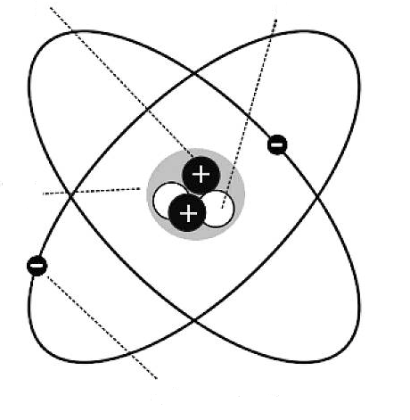

1. **Name the three states of matter?**

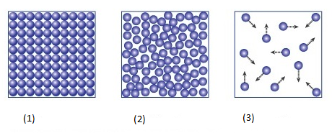

**1………………. 2……………… 3………………..**