Name___________________________________________________________________________________________________

# Simple Machines Review

Part A: Match the name of the simple machine to the picture. Write the correct letter on the line.

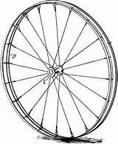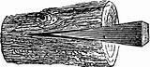1. wedge __________ a. d.

1. 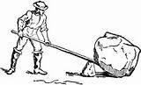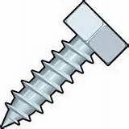wheel axle _________
2. lever
3. pulley

__________ b. e.

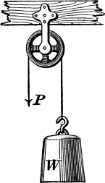__________

1. 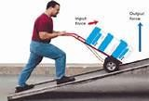inclined plane __________ c. f.

6. screw __________

Part B: On the lines, write the simple machines that make up the compound machine.

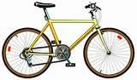7.

___________________________________________________________

___________________________________________________________

8. _______________________________________________________________



.

_______________________________________________________________

9. ________________________________________________________

_________________________________________________________

Part C: Short Answer.

1. What is the name of the part a lever balances on?



____________________________________________________________________________________

1. Simple machines make work _.
2. Choose a simple machine and describe its form and

function.

______________________________________________________________________________________

______________________________________________________________________________________

______________________________________________________________________________________

______________________________________________________________________________________

Name_______________KEY____________________________________________________________________________________

# Simple Machines Review

Part A: Match the name of the simple machine to the picture. Write the correct letter on the line.

1. wedge _____d____ a. d.

1. wheel axle ____a____
2. lever
3. pulley

____b_____ b. e.

____f_____

1. inclined plane ____c_____ c. f.

6. screw _____e____

Part B: On the lines, write the simple machines that make up the compound machine.

7.

____________wheel and axle, lever (and gear, not in our

standards)

__________________________________________

8. _________lever, wedges and screw____________________________



.

_______________________________________________________________

9. _______wheel and axle, lever____________________________

_________________________________________________________

Part C: Short Answer.

1. What is the name of the part a lever balances on?



_________A lever balances on a fulcrum.____________________________________________

1. Simple machines make work _______________easier _.
2. Choose a simple machine and describe its form and

function.

___________________answers will vary_________________________________________________

______________________________________________________________________________________

______________________________________________________________________________________